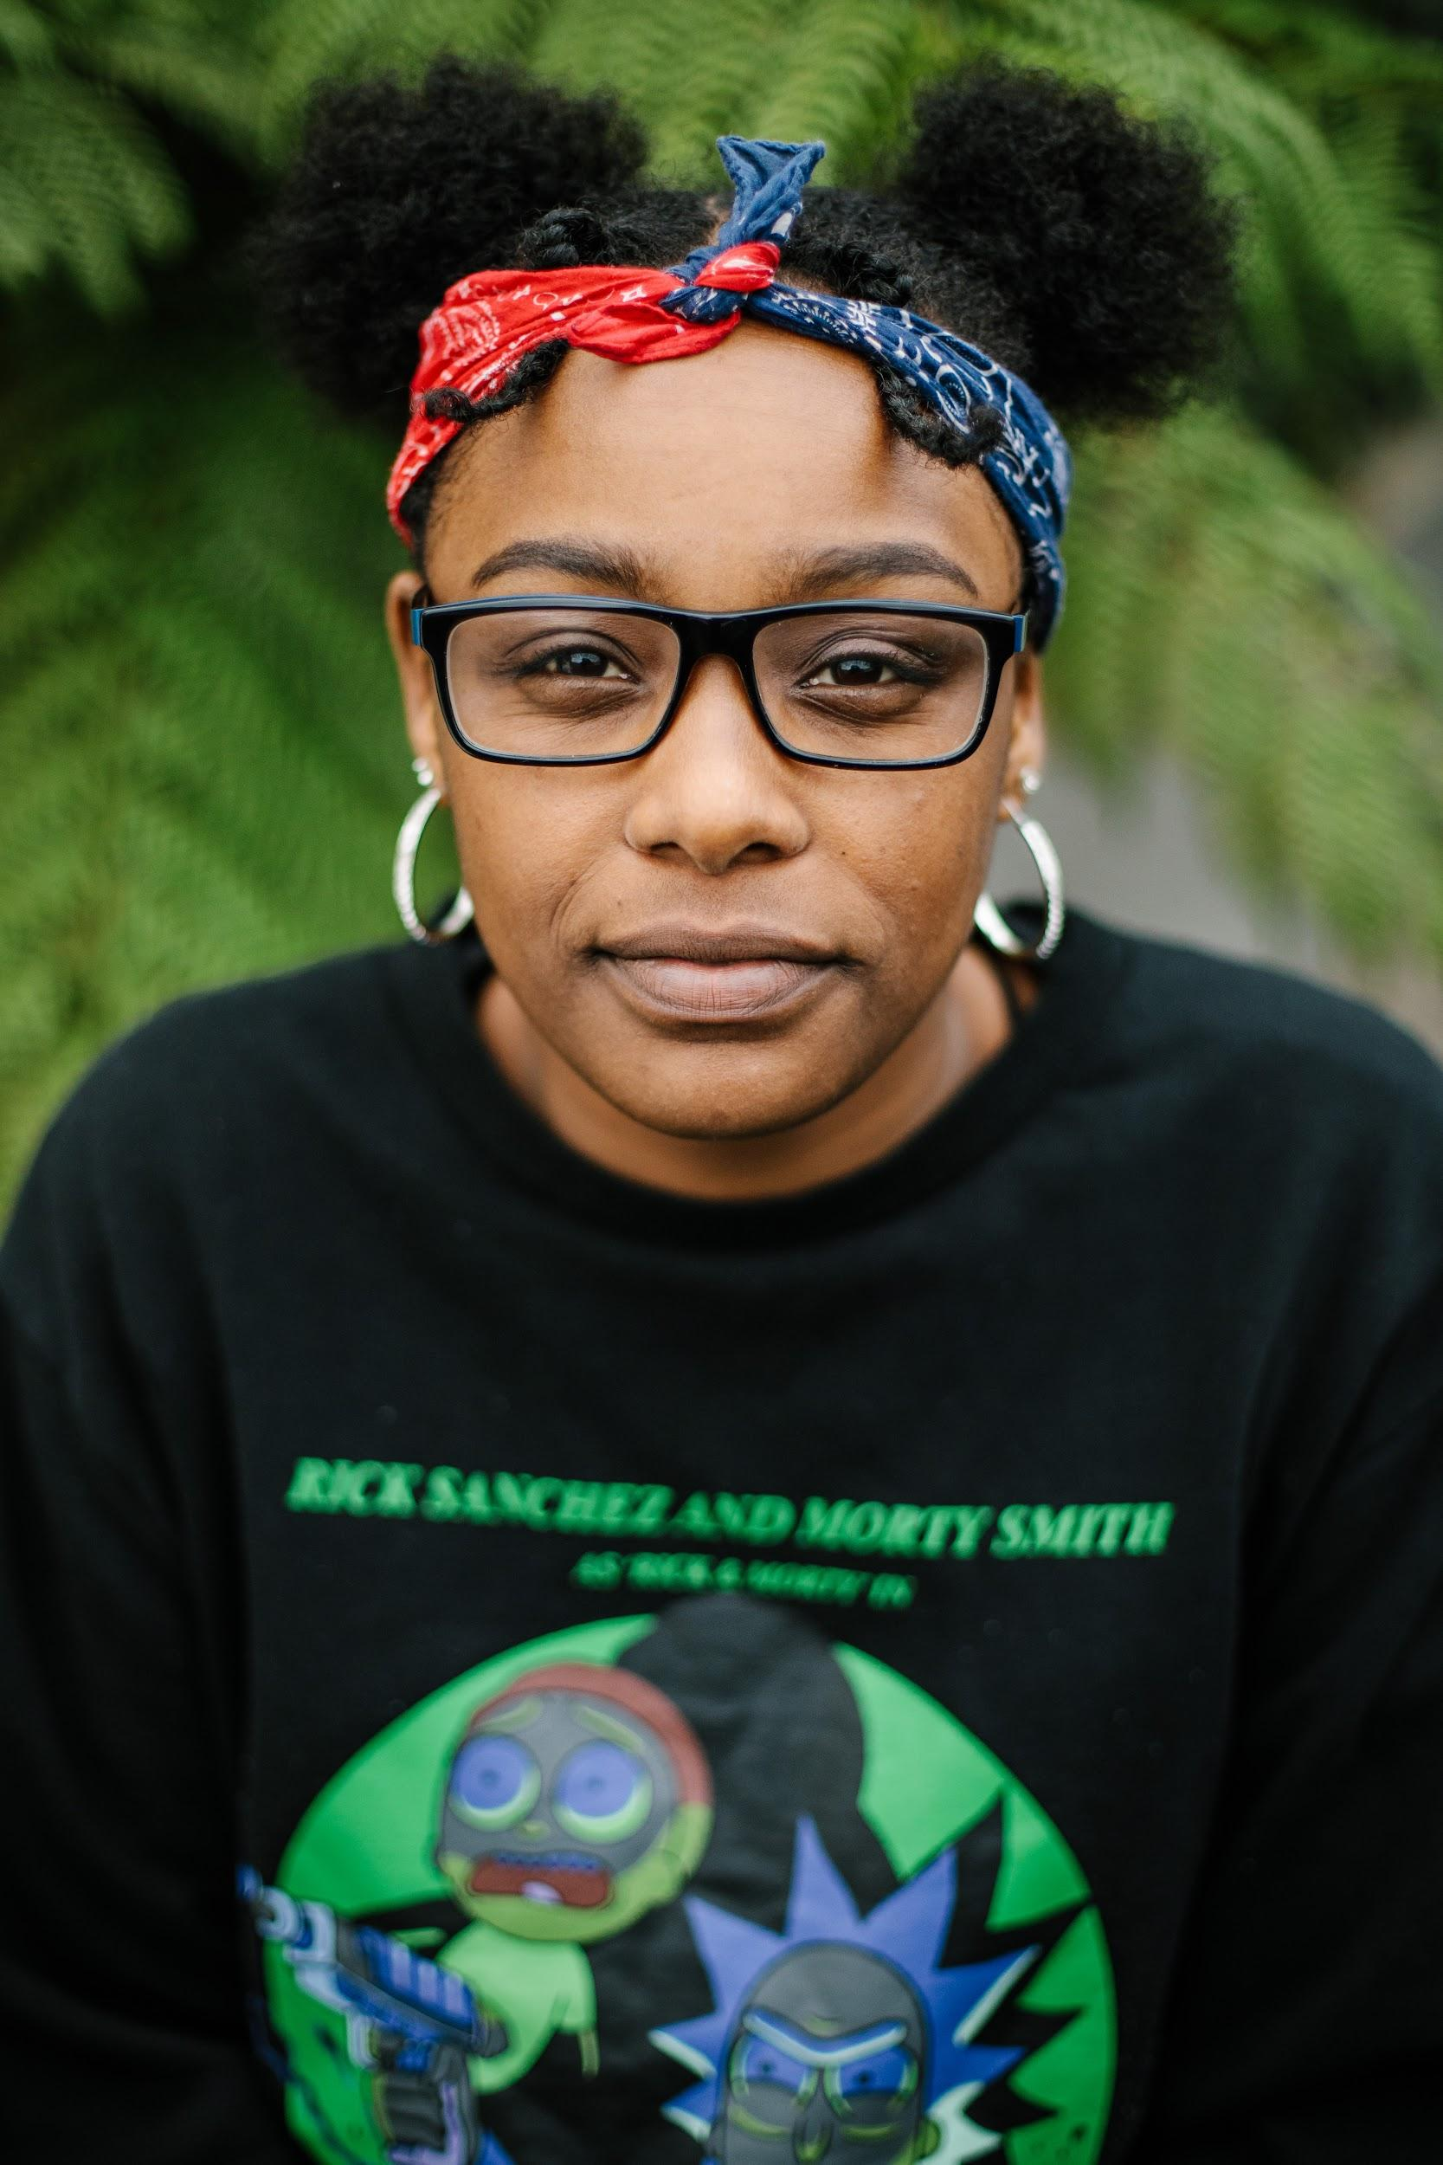

Bashiie is a Multi-creative artist, specialising in artists development.
Bashiie has worked with theatres, venues and creative spaces and government run organisations across London and the wider UK including:
The Bush Theatre, The Lyric Hammersmith, The Tom Thumb Theatre and the Young Vic.
She as just finished her Traineeship at Talawa Theatre Company, as part of the Stage One Placement and is currently the community assistant there.
Her work focuses on working with Care Experienced young people and finding financially sustainable ways of working with artists from marginalised backgrounds.
She is most proud of her collaborative work with the Kiln as an Associate artist and her co-production work with Peer Power UK, running empathy and co-production training with secure estates, the NHS and social services.

As a Producer, Bashiie has curated several events and productions, including her, self-written play Memories - a piece of work exploring her experiences of the care system and her West London Monologue Lab, which encourages writers and actors to site read and perform pieces in tandem and her information sharing classes on: Writing from lived experience and CV Training.

Bashiie is the Artistic Director of Care to Culture - a company focused on championing lived experienced young people so they can have better access into the arts as a creative rather than just participants
Bashiie believes that information sharing is the best way to destroy toxic environments and encourage self advocacy.

Her plan is to use Care to Culture to deliver sessions that are far and few between for free or for a cheap price that enables others to access the arts through "unconventional" means. "Knowledge is power and power creates rifts"

