Easy Read Information and Application for Birmingham Hippodrome Access and Inclusion Advocates

If you need any help filling out this application, please Email our Access Coordinator Charlotte, charlotteboyer@birminghamhippodrome.com

You are applying for  Birmingham Hippodrome Access and Inclusion Advocates | 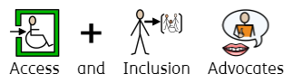  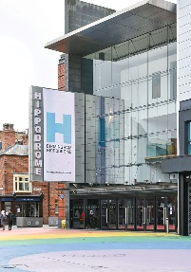
We need to receive your application by Sunday 21st April. | 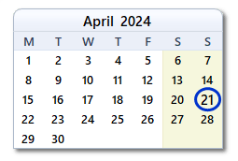
How to complete your application

- Complete the online application form here (please note there is an immersive reader top right of the form if required)

- Record your response (audio or video) and upload it here

- Hand write or type your responses using this easy read application and Email it to charlotteboyer@birminghamhippodrome.com

What is the Access and Inclusion Advocates Programme?
The Access and Inclusion advocates programme will play an important role in working with us to ensure we can become the most accessible venue of our scale in the UK. | 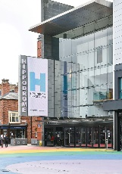  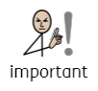
The Access & Inclusion Advocates will play a central role in supporting us to make this a reality, ensuring that we are able to break down barriers for individuals and communities. | 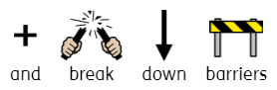
The new programme will launch in May
Individuals who are part of the programme will…  - Engage with sector specialists, each other and Birmingham Hippodrome staff.  - Have opportunities to develop their knowledge and network.  - Be able to understand what we already do and challenge our thinking to ensure we build more equity together.  - See live performances both on our stages and across the city. | 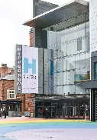  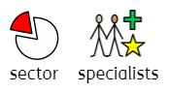  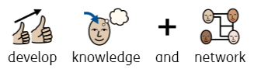  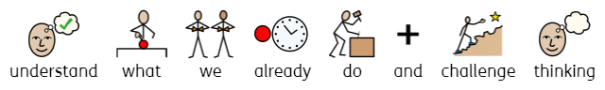  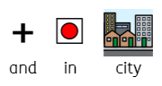  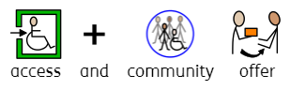
Who is it for?
We are particularly looking to hear from people who have lived experience of:  - Disabilities  - Being a carer or support worker  - Facing barriers to engaging in theatre and the arts  - Working with community groups across the city  - Being an artist/creative in the city  - Providing accessible services/provision  - Health and social work including mental health, care system, criminal justice system  - Working in or accessing SEN school provision or day centre services | 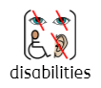  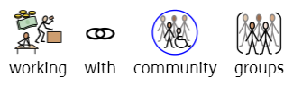  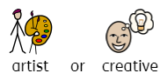  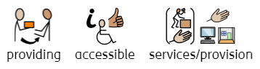  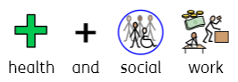  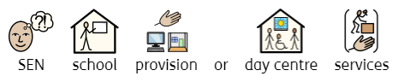  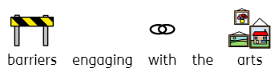  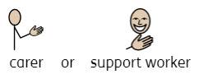
We are also keen to hear from applicants from all sections of society and positively encourage applications from people who are underrepresented in our sector, including those from:  - Working class background  - Ethnically diverse backgrounds  - Care leavers  - The LGBTQ+ community | 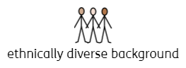  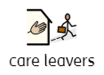
We are committed to ensuring that the programme is inclusive, diverse and representative of our city-region. | 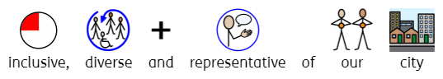
The programme is for anyone age 18+ living in the West Midlands. | 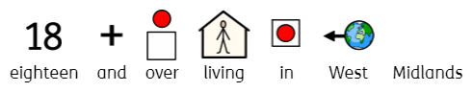

What is the commitment?
The Access & Inclusion Advocates will meet monthly for in-person sessions at Birmingham Hippodrome on Tuesdays 6-8pm. | 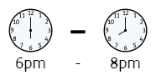  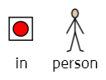
There will also be opportunities to see shows and attend events that sit outside these times.
There is no cost associated with being part of the Access & Inclusion Advocates programme.

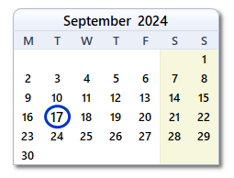
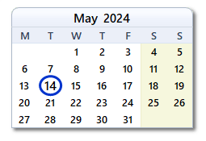
The dates for the programme are:
Tuesday 17th September 2024
Tuesday 16th July 2024
Tuesday 18th June 2024
Tuesday 14th May 2024
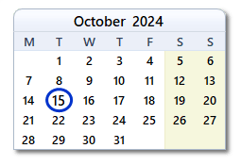
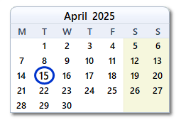
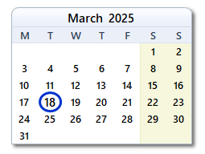
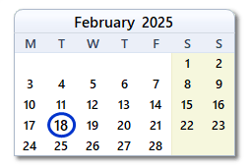
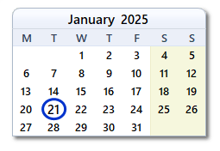
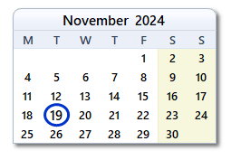
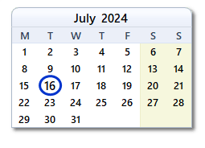
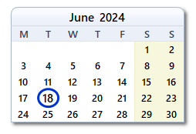
Tuesday 15th April 2025
Tuesday 18th March 2025
Tuesday 18th February 2025
Tuesday 21st January 2025
Tuesday 19th November 2024
Tuesday 15th October 2024

Access & Inclusion Advocates will benefit from the following:
- A Complimentary ticket to 4 shows a year  - A Birmingham Hippodrome Friends Membership  - 15% discount on food and drink at Birmingham Hippodrome  - Access to ticket offers on selected performances  - Invites to special events and Relaxed Performances  - Opportunities to meet the Board and senior leadership team at Birmingham Hippodrome  - Travel bursaries (for those that require support, please advise us in your application so we can discuss in more details)  - Use of our Artists Lounge, with access to free WIFI and hot drinks  - Opportunities to see behind the scenes of what we do, including a backstage tour  - Opportunities for personal development, developing your networks and further opportunities to connect to Birmingham Hippodrome | 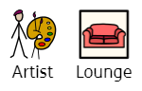  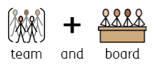  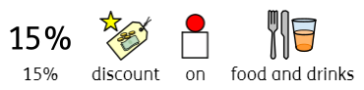  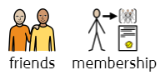  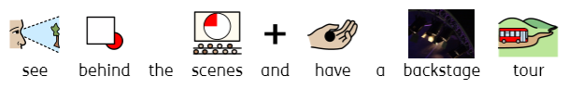  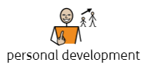

I’m interested, what next?
Applications are now open – the deadline to apply is Sunday 21 April.
Complete the online application form here (please note there is an immersive reader top right of the form if required)

Record your response (audio or video) and upload it here

Hand write or type your responses using this easy read application and Email it to charlotteboyer@birminghamhippodrome.com
The easy read application is on the next page

Full Name

Email Address

Phone Number

Date of birth

Pronouns

Postcode

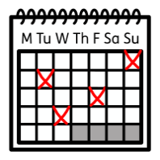

Your availability for the dates of the programme (see page 5)

- Please tell us about yourself?

This can include what your skills, interests and professional or personal background is in relation to access and inclusion, and if you have had a connection with the Hippodrome previously.

- Please tell us how you would define access and inclusion, and why is it important to you?

If you have experiences of advocating for yourself or other people, we would love to hear about them.

- What areas of access and inclusion do you want to advocate for within the theatre industry?
This may include supporting ticket prices, increasing the number of Relaxed Performances, seeing a more diverse programme, etcetera

- Anything else you like to tell us?

This includes what support you would need to make this programme accessible to you.

Additional Information
We are running two information sessions where you can meet some of the team, find out more about the programme and the application process and ask any questions you might have.  Friday 5 April 6-7pm – Online information session.  Monday 15 April 6-7.30pm – In person information session at Birmingham Hippodrome.  We would encourage you to come in person if you would benefit from seeing the space and meeting the team face to face.  If you would like to sign up for either of the information sessions above, please email our Access Coordinator Charlotte, charlotteboyer@birminghamhippodrome.com | 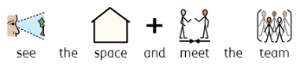  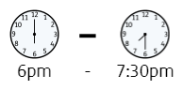  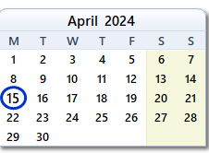  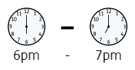  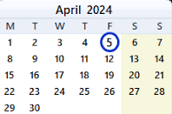  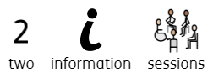
For those that are successful in their initial application, we will be holding a workshop to select the final cohort. This will take place on Wednesday 1st May 6-8pm at Birmingham Hippodrome. | 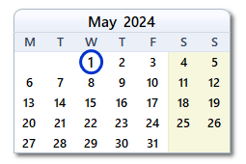
If you have any questions or need any additional support to apply, please get in touch with Charlotte - charlotteboyer@birminghamhippodrome.com

