Easy Read Guide
Dear Zoo
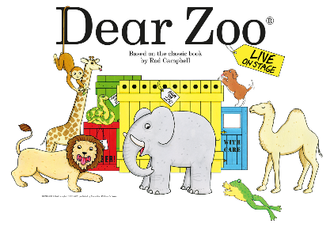

We are looking forward to seeing you at
Dear Zoo in the Patrick Studio
at Birmingham Hippodrome.
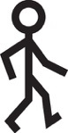 | How to find the Patrick Studio
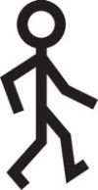  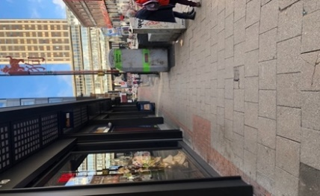  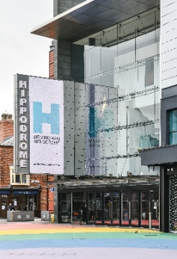 | This is Birmingham Hippodrome.  Walk around the side of the theatre – to The Patrick Studio entrance on Thorp Street.
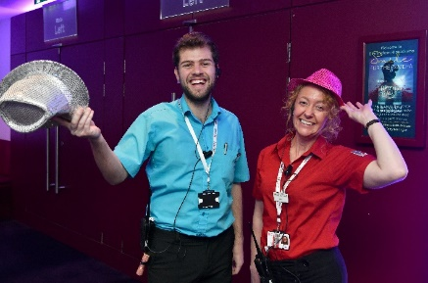  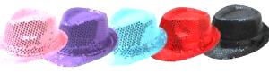 | Go through these doors and you will be met by a person in a sparkly hat.
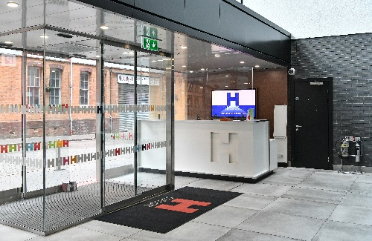  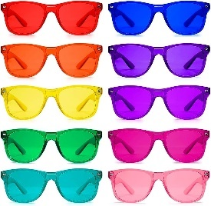  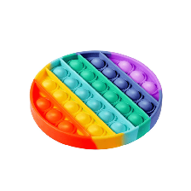  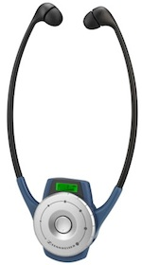 | This is where you will have your tickets scanned and your bags checked for safety.  We have ear defenders, fidget toys, colour therapy glasses and headsets for audio description and show relay. If you need them, just ask someone in a sparkly hat.
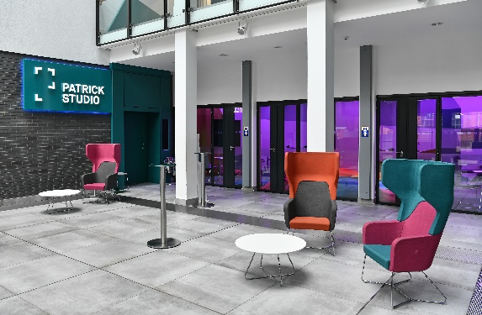 | You can wait here before you go into the Patrick Studio.  There may be other people waiting here to see Dear Zoo too.
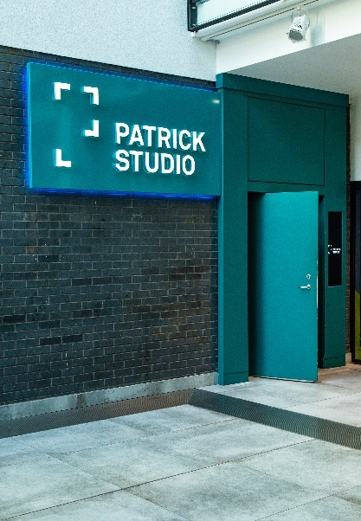 | If you are sitting towards the front row, you can use this door to the Patrick Studio which is in the area where you might have been waiting.
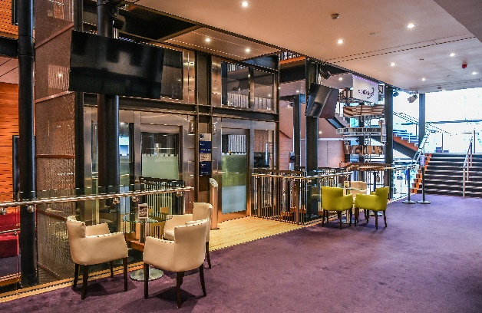  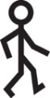  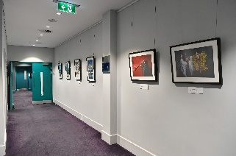  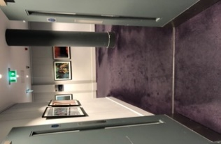  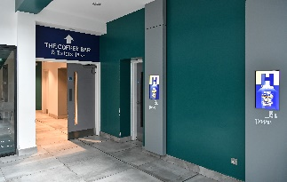 | If you are sitting at the back of the Patrick Studio, open the grey doors and follow the purple carpet to the left.  Next, go through the blue doors and turn right.  You can take the lift or the stairs to level 3.
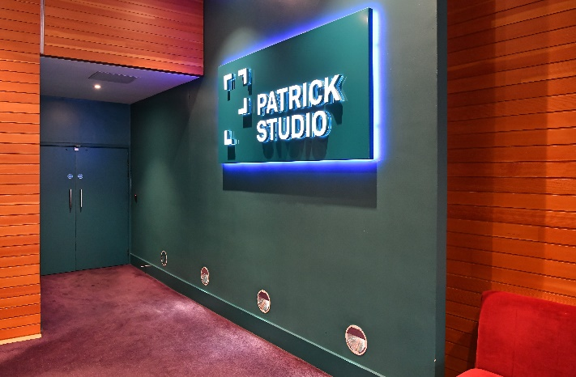 | This is what the doors to the Patrick Studio on level 3 look like.  If you are coming out of the lift the doors will be on your left.
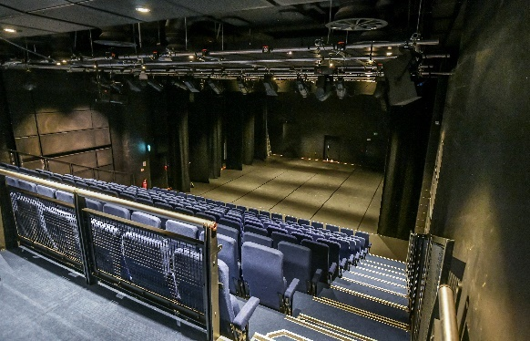  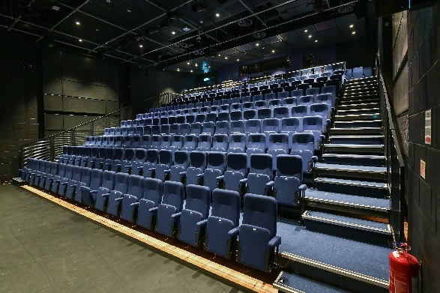 | This is inside the Patrick Studio when these doors are open.
 | Chill out spaces and toilets
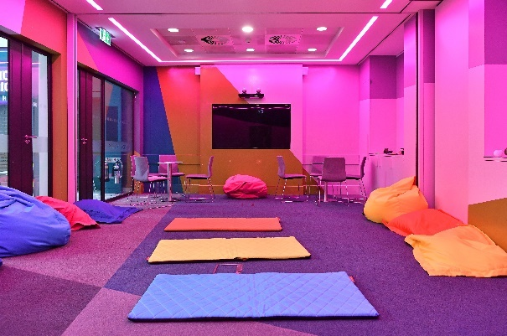  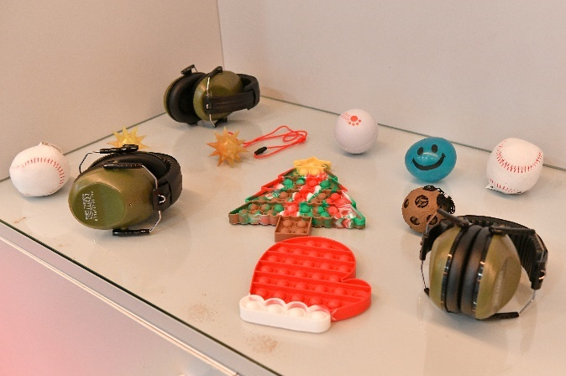 | There will be a space to go to if you need a little break from Dear Zoo.  There are cushions, soft mats and fidget toys and sensory lighting to relax in.  You can go back to your seats whenever you want.  Just ask someone in a  sparkly hat to show you where it is.
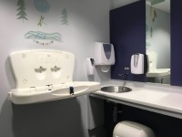  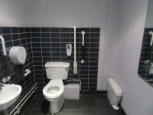 | There are accessible toilets on level 2 and level 3 and a parent and baby room on level 2. Just ask someone in a sparkly hat to show you the way.
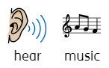  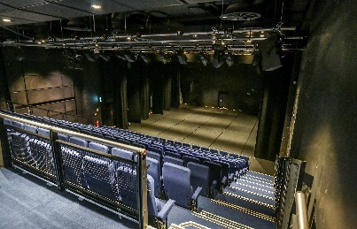  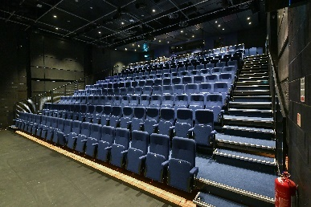 | You will then go into the Patrick Studio which looks like this. Music will be playing as you walk in.
Dear Zoo – The Characters
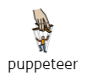  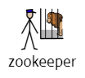  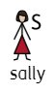  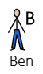 | Aidan will be playing the character of Ben.  Louise will be playing the character of Sally.  Max will be playing the character of Sam, the Zookeeper.  Sam and Kelly are puppeteers, they bring all of the animals in the zoo to life, as they are not real animals, just puppets. Sam sometimes plays Ben and the Zookeeper and Kelly sometimes plays Sally too.
 | Dear Zoo – The Story
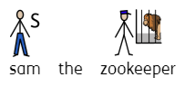  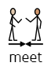  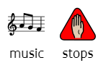 | The music that was playing as you walked into the Patrick Studio will stop and we will meet Sam the Zookeeper! Sam will introduce himself, the zoo and the story which is all about a Zoo getting a letter from someone who wants a pet.
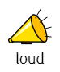  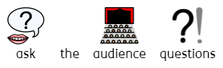 | Sam will ask the audience some questions and will want everyone to answer. It might get quite loud during this part. Our characters ask the audience a lot of questions during the show and love it when you all join in, so if it does feel too noisy you can borrow some ear defenders.
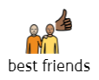 | Next, we meet Ben and Sally who are best friends.
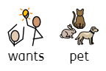  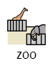 | Sally notices Ben holding a letter. He tells her that he has written to the zoo so they can send him a pet.
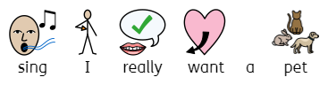 | Ben and Sally then sing the song I really want a pet! Then, they go off to post Ben’s letter to the zoo.
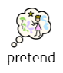  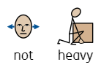  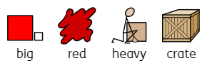  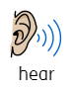  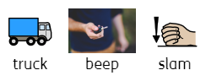 | Next, we hear a truck stopping, a beep and a door slam this is when we know Sam the Zookeeper is arriving. He meets Ben and says that he has a delivery for him from the zoo. Ben and Sally help Sam with a really heavy crate – but don’t worry it’s not really heavy they are just pretending. Sam leaves and Ben and Sally start to get excited about the big crate.
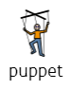  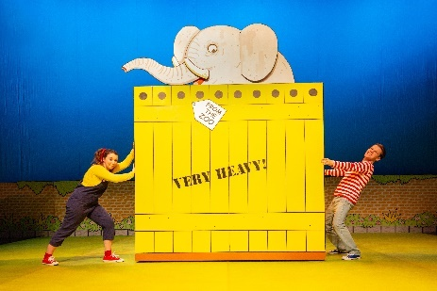 | An elephant appears out of the crate! This is one of our first animal puppets that we will see because remember, all of our animals in the story are puppets.
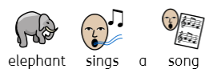  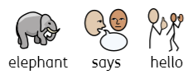 | Elephant says hello – this might be quite loud. Elephant then sings a song called Yes, I’m an Elephant.
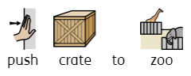  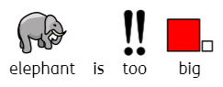 | After singing the song, the elephant falls asleep. And whilst the elephant sleeps Ben and Sally say he is too big so they push the crate back to the Zoo.
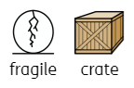  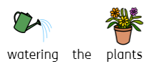 | Whilst watering the plants we hear a truck stopping, a beep and a door slamming which means that Sam the Zookeeper arrives! This crate is a fragile crate, meaning they have to be careful or what’s inside might get hurt.
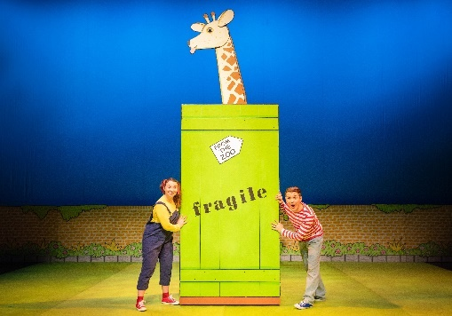 | But because they are being so careful they don’t notice the giraffe that is inside the crate!
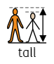  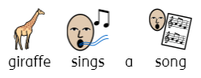 | The giraffe sings a song called Giraffes Are Tall! This makes Ben and Sally want to be tall – you can join in being as tall as possible with them.
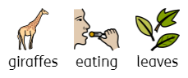  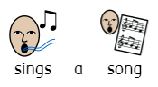 | Sally then sings a song called Munch, Munch which is all about giraffes eating leaves.
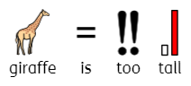 | Ben and Sally become tired after pretending to be tall and munching on leaves. They realise that giraffe will be too tall for a pet, so they gently push giraffe back to the zoo.
 | After saying goodbye to giraffe. We hear a truck stopping, a beep and a door slam and Sam the Zookeeper arrives.
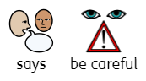  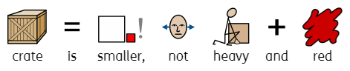 | Ben and Sally notice that this crate is smaller, not as heavy and the colour red. Sam tells them to be careful, very careful.
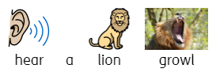  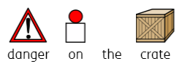 | Sam leaves and Ben and Sally wonder why they have to be careful and then notice Danger on the crate! We hear the lion growl!
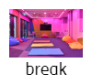  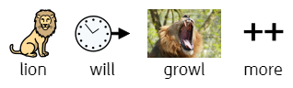 | We then hear a lion growl! the lion will growl a few more times during this part of the story so please use ear defenders or take a break outside if you are finding it too scary, we can let you know when it’s gone.
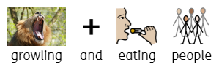  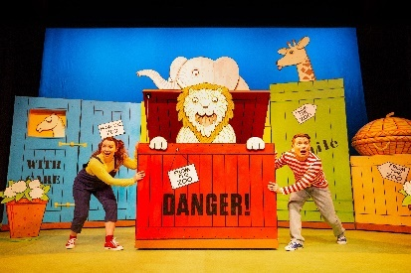 | Lion sings a song called I’m A Lion which is all about growling and eating people for lunch and tea! Remember this is all pretend and Lion is just a puppet.
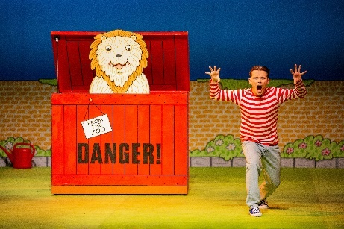  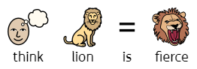  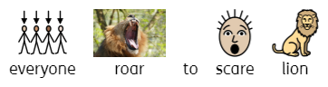 | Ben and Sally think Lion is very fierce, they think that roaring at Lion will show him they are not afraid. They will ask you to help them roar. Because we are a lot louder than Lion.
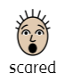  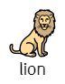 | Lion does get scared, and Ben and Sally carefully and quietly push Lion back to the zoo as they think Lion is too fierce.
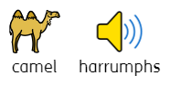  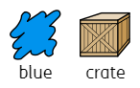 | Sam the Zookeeper arrives again! This time with a blue crate. Ben and Sally look inside and it’s a camel! The camel harrumphs and Ben and Sally look a bit scared but don’t worry they are just pretending.
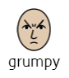  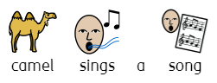  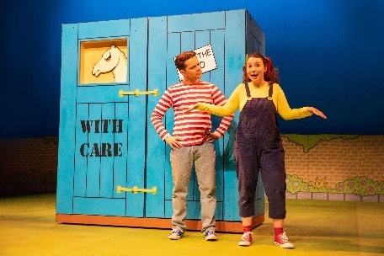 | Ben opens the crate to reveal the camel and camel sings a song called They Call Me Humpy because of his hump! The song reveals that he is quite grumpy which makes Ben and Sally send him back.
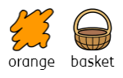  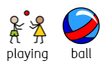 | Whilst Ben and Sally are playing ball – Sam the Zookeeper arrives! This time with an orange basket and Sam tells them to be gentle.
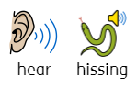  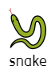 | We hear a hissing sound which Ben and Sally think is scary! But don’t worry, it’s all pretend. Can you guess what it is? It’s a snake!
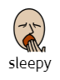  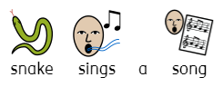  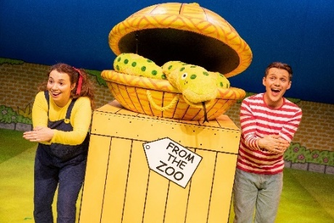 | Sanke is a happy Snake who sings the Hiss, Hiss Song which makes Snake want to curl up and sleep. Ben and Sally want Snake to fall asleep so ask for your help to sing the song.
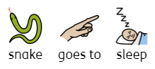  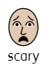 | Snake falls asleep and Ben and Sally decide to send Snake back as its too scary.
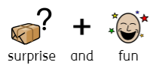  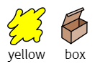 | Whilst Ben and Sally are playing another ball game. Sam the Zookeeper comes back this time with a yellow box but not as big as the elephant’s yellow box. Sam says this will be a nice surprise and they will have lots of fun with this animal.
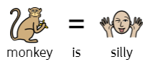  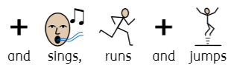  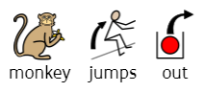  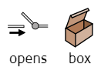 | Ben tries to open the box and a monkey jumps out. Monkey is very, very silly and excited. Monkey sings to us and is running and jumping all over the place.
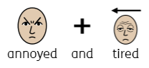 | Ben and Sally seem annoyed and tired at Monkey.
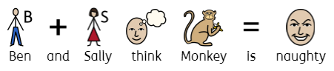 | Ben and Sally think Monkey is too naughty so send him back to the zoo.
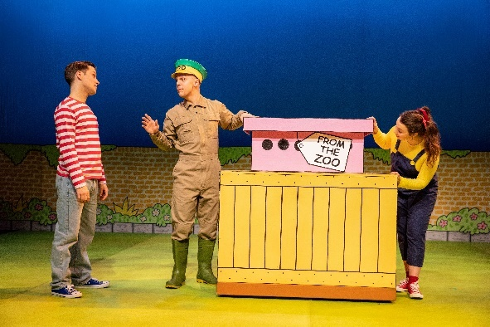  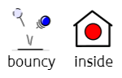 | Ben and Sally are in the garden counting the flowers. Sam the Zookeeper arrives again, this time with a pink box. Sam tells Ben and Sally to be gentle and that there is someone rather bouncy inside!
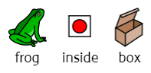  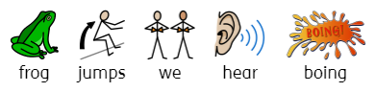 | Ben lifts the lid off, and a frog is inside. Every time Frog hops, we hear a BOING sound.
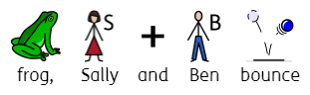 | Frog bounces all around the stage and Ben and Sally join in – you can too.
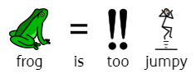  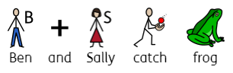 | They try very hard to get frog back into the cage and when they do they decide to send frog back a frog is too jumpy.
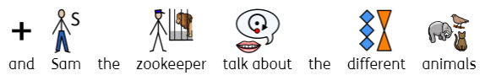  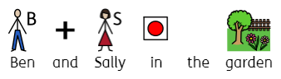 | Ben and Sally are in the garden when Sam arrives again. They talk about all of the animals that Sam has brought to them and why they were not quite right.
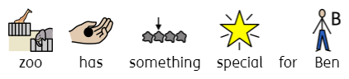 | Sam says that the Zoo has thought very hard and has something special for Ben.
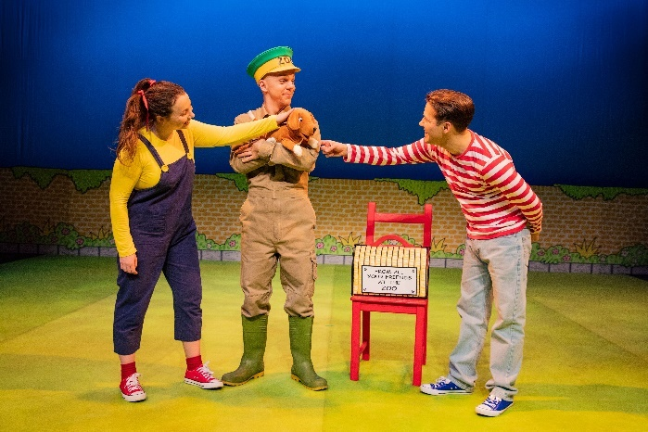 | Sam hands Ben a basket and inside is a… PUPPY. Ben thinks the puppy is perfect.
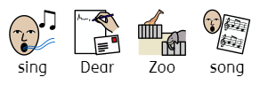  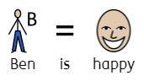 | Ben is so happy that we all sing the Dear Zoo song together.
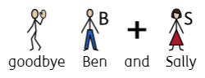 | After the song Ben and Sally say goodbye to us.
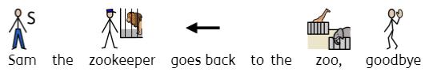 | Sam says he is heading back to the Zoo and says goodbye to us too.
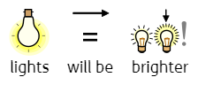  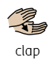  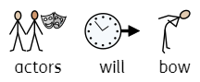  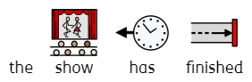 | At the end of the show the actors will take a bow to music. You can give them a clap! When they leave the stage, they music will keep playing and the lights will get brighter. The show has now finished.
It’s time to go home now or back to school.

Thank you so much for coming visit us at Birmingham Hippodrome.

We hope you enjoyed watching Dear Zoo.

