Bamboo

By

NoFit State Circus

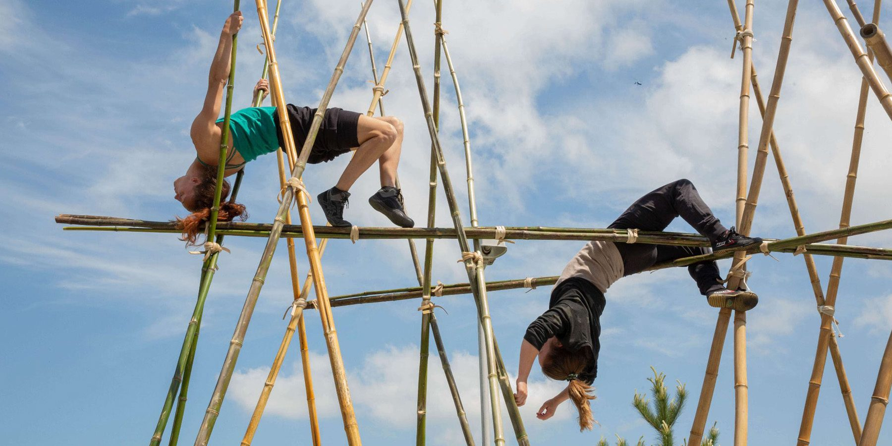

|  |  |
| --- | --- |
| Time | 40 mins  But you can come and go as you please. |
| Who is it for? | All ages |
| Where is it? | 1000 trades square |
| Access | This is a text free performance. It does contain speech, but it is not needed to understand the story.  This performance will be Audio Described and will have an accessible viewpoint on Sunday 25th August at 2pm.  Chair Icon Vector Art, Icons, and Graphics for Free DownloadAudio Description - Screen Machine  Access Hub outside. Weekender Festival image. The façade of the Access Hub near the East entrance to the Bullring. It has a colourful border around the front and two big glass doors.The nearest Access Hub is on Rotunda Square . |
| Content warnings | This performance contains drumming which might be loud. |
| Main themes | Circus    Live music    Comedy  Acrobatics |

What will happen during the performance?

Find out more

<https://www.birminghamhippodrome.com/calendar/bamboo/>

https://www.instagram.com/nofit_state_circus/  
https://www.facebook.com/nofitstatecircus/  
https://twitter.com/NoFitState

Contact us

[charlotteboyer@briminghamhippodrome.com](mailto:charlotteboyer@briminghamhippodrome.com)

