Blanko

By

JOHNman

Sunday 25th & Monday 26th August

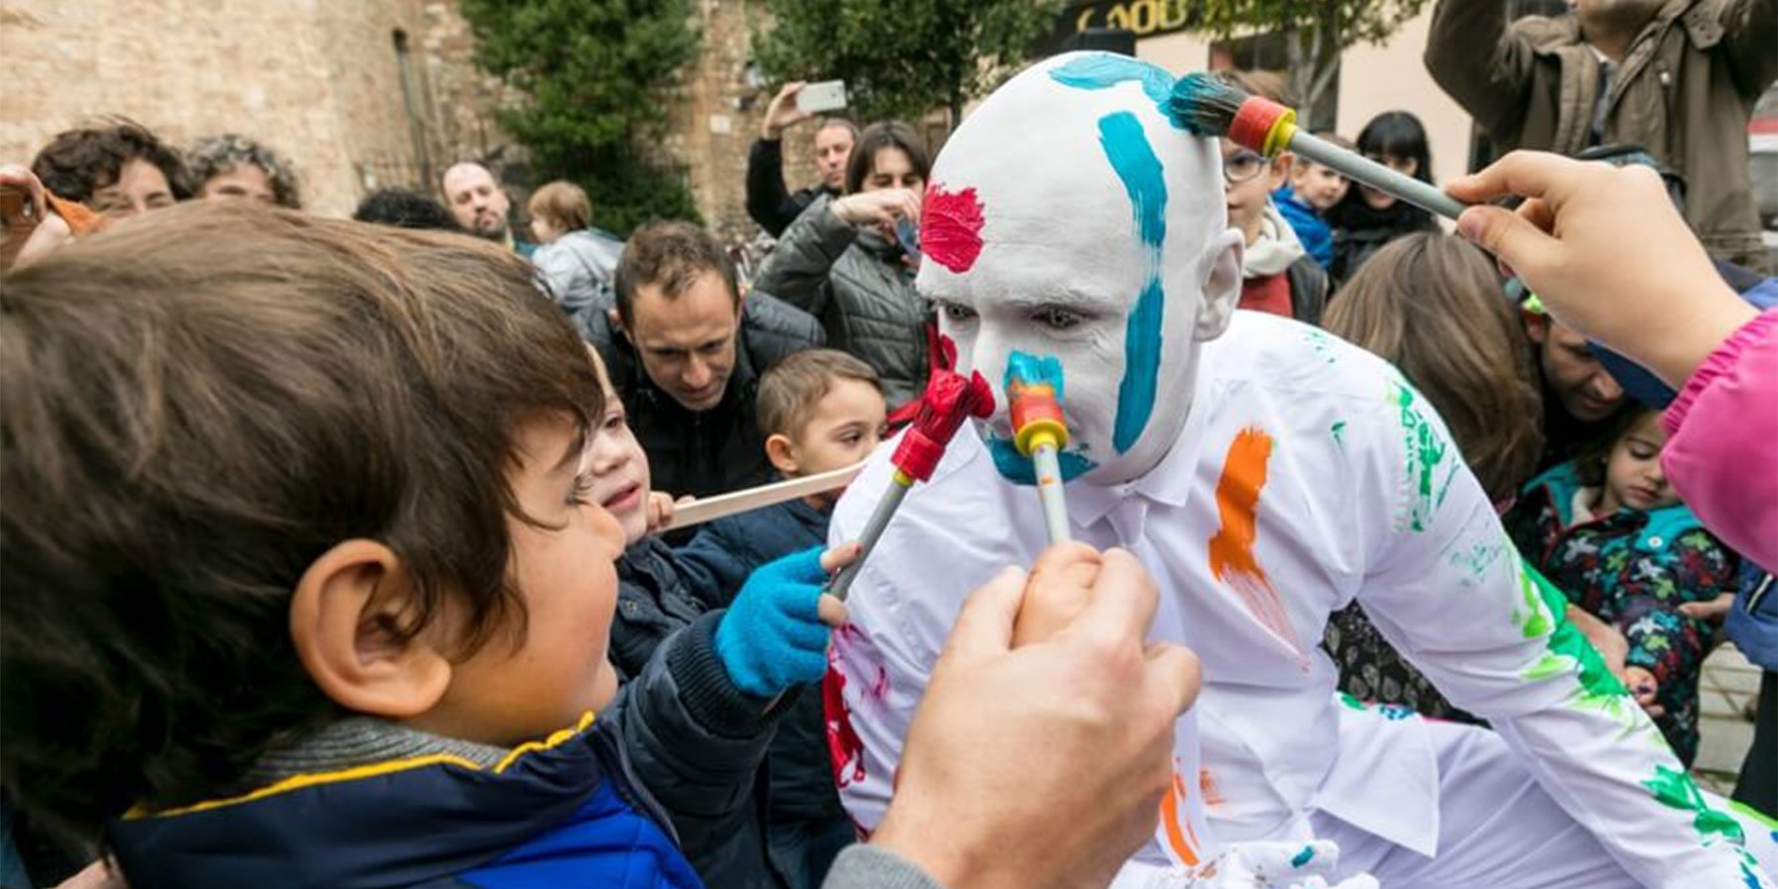

|  |  |
| --- | --- |
| Time | 1:15 – 1:45pm  3:15 – 3:45pm  3:45 – 4:45pm  You can come and go as you please. |
| Who is it for? | All ages. |
| Where is it? | 1:15 – 1:45pm & 3:15 – 3:45pm shows at St Martin’s Square    3:45 – 4:45pm show at Access Hub at Rotunda Square |
| Access | Events with Access Features | Camden People's Theatre  The 3:45 – 4:45pm shows are relaxed performances.    This performance does not rely on text or speech.    It moderately relies on visuals.    Please find an Access Host in a yellow t-shirt for further assistance.  The nearest Access Hub is at Rotunda Square. |
| Content warnings | There will be lots of audience interaction.    There is paint involved. |
| Main themes | Art |

What will happen during the performance?



During the relaxed sessions, you will have 30 minutes of

free painting.

You will then meet a human statue called Blanko who

will be dressed in all white.

You will have the chance to paint Blanko if you want to.

Blanko will be covered in paint by the end!

Some bits will be funny. You will hear people laughing.

Find out more

<https://www.birminghamhippodrome.com/calendar/blanko/#performance_content>

Website Links: <https://coventgardenentertainment.co.uk/performers/blanko-human-statue/>

<https://international.johnman.de/blanko.html>

Facebook: <https://www.facebook.com/JOHNman.LivingDoll?ref=hl>

Phone: +49 172 8338229

Email: [johnman@johnman.de](mailto:johnman@johnman.de)

Contact us

[charlotteboyer@birminghamhippodrome.com](mailto:charlotteboyer@birminghamhippodrome.com)

