Bubble Extravaganza

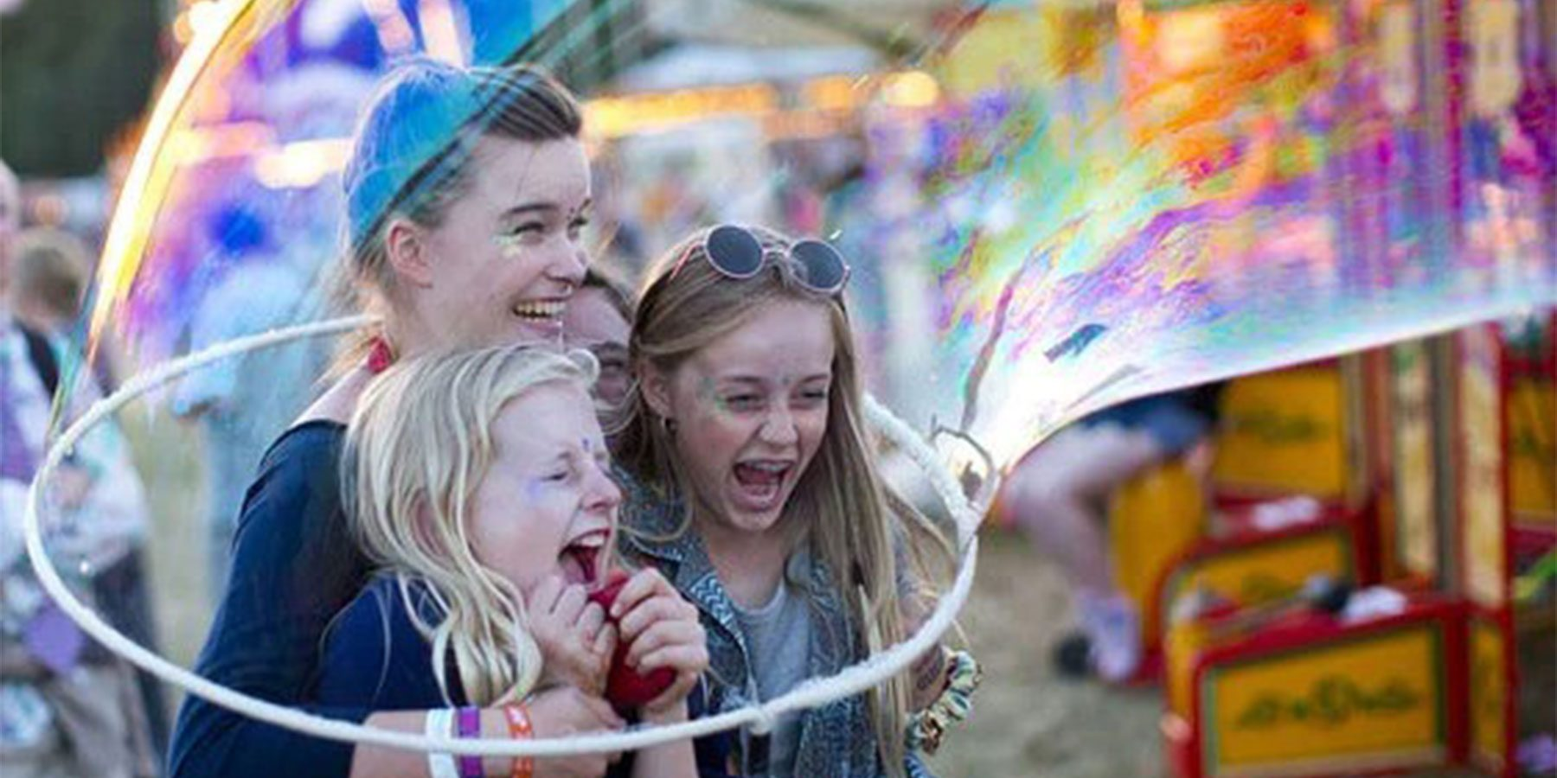

|  |  |
| --- | --- |
| Time | Saturday 24th August  1:15pm and 3:15pm  Sunday 25th and Monday 26th August  1:15pm, 3:15pm, and 5:15pm |
| Who is it for? | All ages |
| Where is it? | Saturday 24th August  St Martin’s Square    Sunday 25th and Monday 26th August  1000 Trades Square, New Street Station |
| Access | The piece moderately relies on visuals.    Please find an Access Host in a yellow t-shirt for further assistance.  Access & Info Point - Hippodrome Square. Weekender Festival image. A small yellow tent on the rainbow square outside the Hippodrome.The nearest Access & Info Point is on Hippodrome Square. |
| Content warnings | There will be lots of audience interaction.    Bubbles will be blown.    There will be giant bubbles created around audience members.    Bubbles may silently pop very close to you or over you. |
| Main themes | Theatre    Bubbles    Comedy |

What will happen during the performance?

Bubbles of different sizes will be blown all around you.

There will be giant bubbles that may surround you.

All the bubbles will silently pop. This may happen very close to you or over you!

Some parts will be funny.

There will be laughter from the audience.

Find out more

<https://www.birminghamhippodrome.com/calendar/bubble-extravaganza/#performance_content>

Contact us

[charlotteboyer@birminghamhippodrome.com](mailto:charlotteboyer@birminghamhippodrome.com)

