Bullring Dance Stage

Saturday 24th and Sunday 25th August from 12pm-6pm.
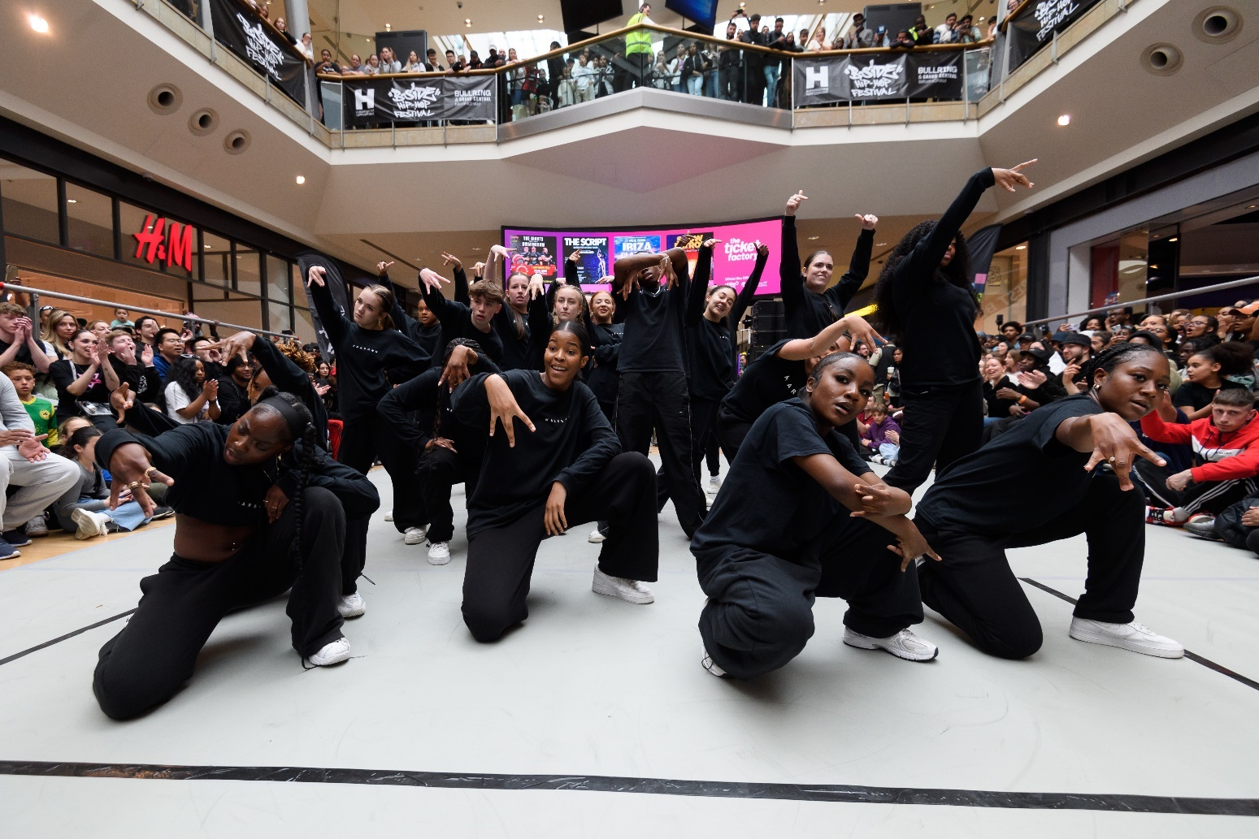

Time   | 12pm-6pm.  Timings of performances below.  You can come and go as you please.
Who is it for?   |   Different dances are for different ages, look at each dance below.
Where is it?   | Bullring Lower Mall West (outside M&S)  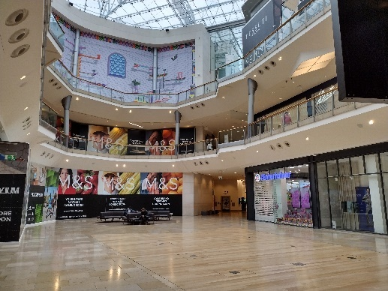
Access   | There will be an Accessible Viewpoint on Level 1 of the Bullring.      There will be BSL and Audio Description for some performances – see below.    
Content Warnings   |   The music might be loud.    You can get ear defenders or ear plugs from the Accessible Viewpoint.

What performances will happen at The Bullring Dance Stage?

SYNERGY
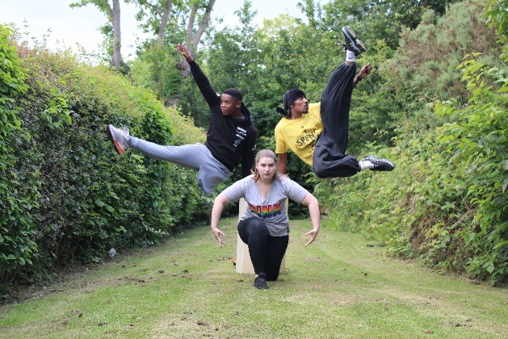

When?   | Saturday 24th and Sunday 25th August  1:15pm & 5pm
Who is it for? | All ages!
About the performance   | This is the first performance of SYNERGY.  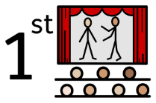  They are a D/deaf and disabled dance company.  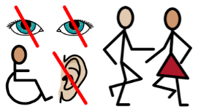
Access | BSL – all performances!  Audio Description Saturday 24th and Sunday 25th at 5pm.
TREAD
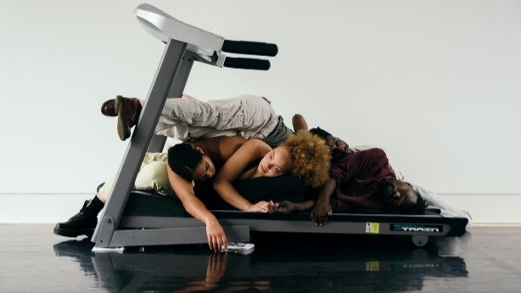

When? | Saturday 24th and Sunday 25th August  12pm & 3:35pm
Who is it for? | All ages!
About the performance | 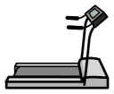  There is a treadmill in the performance.    They will do tricks and dance on the treadmill.  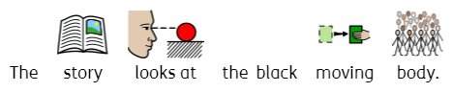  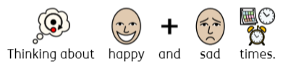
Access | Audio Description Saturday 24th and Sunday 25th at 3:35pm.

SWAN BREAK
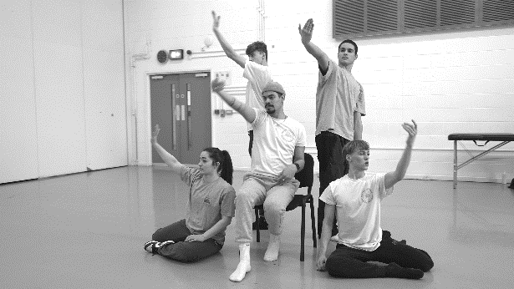

When? | Saturday 24th and Sunday 25th August  1:40pm & 4:35pm
Who is it for? | All ages!
About the performance |   Based on the story Swan Lake.      With street dance and ballet moves.
Access   | Audio Description Saturday 24th and Sunday 25th at 4:35pm.

PERFORMERS COLLEGE LUNA INSPIRED DANCE
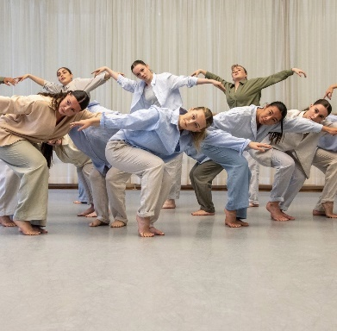

When? | Saturday 24th and Sunday 25th August  1pm & 3:20pm
Who is it for? | Age 12+
About the performance |   Looking at stories of women    The performance explores themes of domestic abuse.
Access | Audio Description Saturday 24th and Sunday 25th at 3:20pm.

CLOSER TO MY DREAMS
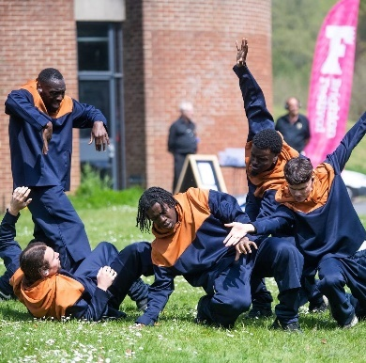

When? | Saturday 24th and Sunday 25th August  12:35pm, 2:55pm & 5:40pm
Who is it for? |   Young people    Dancers    Hip-Hoppers
About the performance | Two brothers want to be dancers.            We see their journey and the friends they make.
Access | Audio Description Saturday 24th and Sunday 25th at 5:40pm.

TORCH OF EXCELLENCE
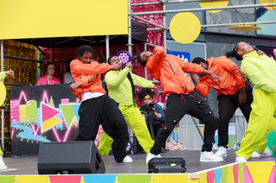

When? | Saturday 24th and Sunday 25th August  2:30pm & 5:25pm
Who is it for? | All ages!  
About the performance |   A celebration of dance.    It will make you feel inspired.
Access | Audio Description Saturday 24th and Sunday 25th at 5:25pm.

KEEP MOVING & FUTURE SHIFT
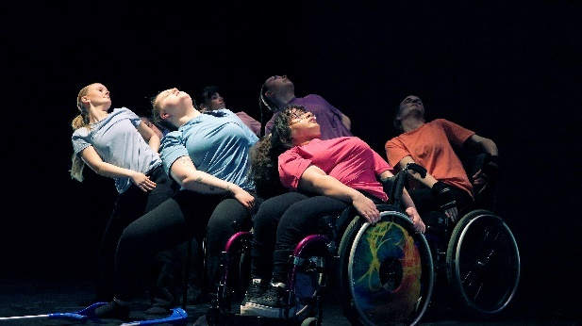

When? | Saturday 24th and Sunday 25th August  2:05pm & 4:10pm
Who is it for? | All ages!
About the performance |   Themes of empowerment, confidence and owning who you are!  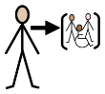  Both groups offer inclusive opportunities for young people.
Access | BSL – all performances!  Audio Description Saturday 24th and Sunday 25th at 5:25pm.

Find out more

https://www.birminghamhippodrome.com/calendar/birmingham-weekender-2024/

Contact us

Charlotteboyer@birminghamhippodrome.com

