Comedy Club 4 Kids
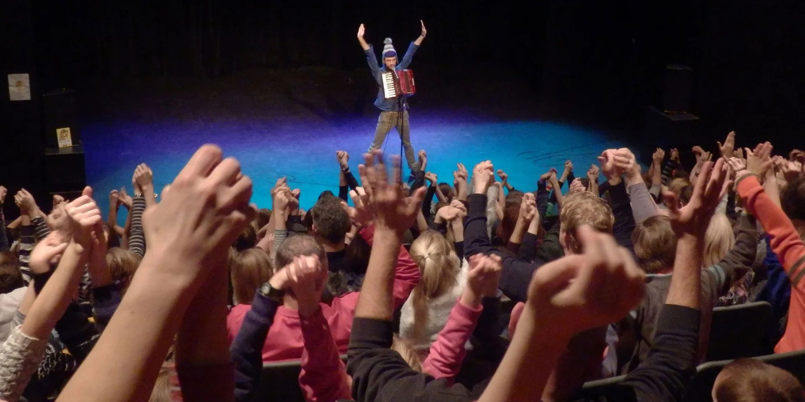

Time   | 40 mins  But you can come and go as you please.
Who is it for?   | Families with children aged 6+
Where is it?   | St. Martin’s Square  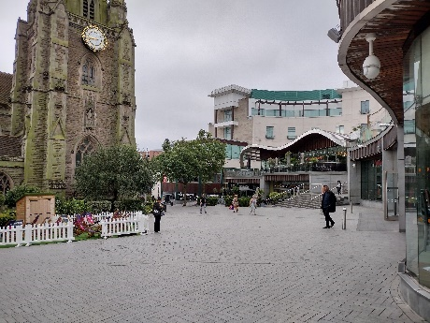
Access   | There will be Audio Described and BSL interpreted performances with an accessible viewpoint on Saturday 24th August at 12:15pm and Sunday 25th August at 5:15pm.          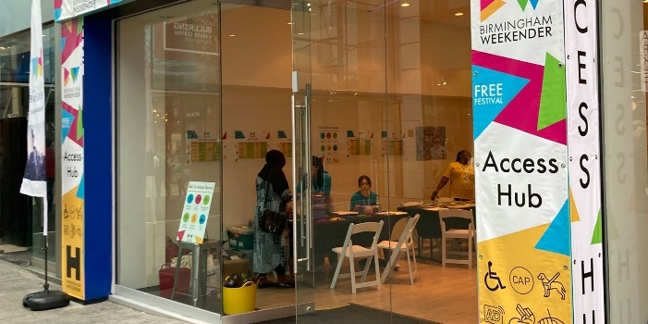  The nearest Access Hub is on Rotunda Square.
Content warnings   | There will be some questions put to the audience by the comics on stage.  
  Main themes |   Stand-up    Musical comedy    Sketches

What will happen during the performance




Sketches and performances
Musical comedy
Jokes and silliness
From comedians on Saturday 24th August
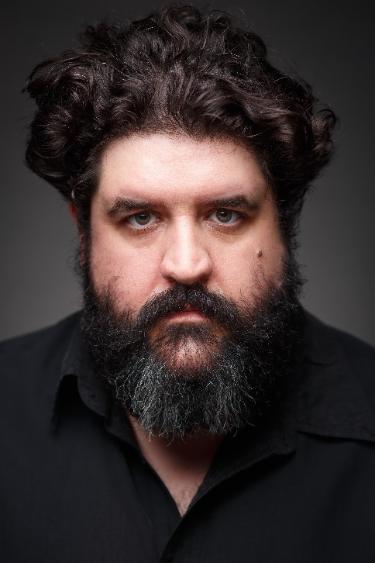


Paul ‘Silky’ White
Rich Sandling
And comedians on Sunday 25th August



Helen Duff


Eleri Morgan

There will be lots of laughter from the audience!

Find out more
https://www.birminghamhippodrome.com/calendar/comedy-club-4-kids/

Website: http://www.comedyclub4kids.co.uk
Twitter Name/Handle: @ComedyClub4Kids
Facebook Address: https://www.facebook.com/ComedyClub4Kids
Instagram: comedyclub4kids // https://www.instagram.com/comedyclub4kids/
Youtube links: https://www.youtube.com/user/comedyclub4kidsUK

Contact us
charlotteboyer@briminghamhippodrome.com



