Hello and Welcome to Birmingham Weekender!

We have 4 FREE fun-filled days for you in Birmingham

from Friday 23rd August – Monday 26th August.

This guide will tell you all about the different events and help you find them!

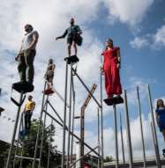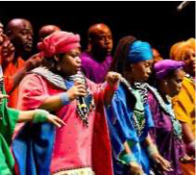

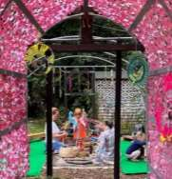 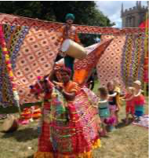 ... circus

and activities

There are lots of performances that you can simply sit and watch as well as activities that you can take part in. These are happening in specific places in Birmingham. There will be special times that they will start and finish. Sometimes you have to book a ticket to make sure you get a place.

Other performances will be roaming all around Birmingham – and we can help you look out for them and tell you when you can see them.

|  |  |  |  |
| --- | --- | --- | --- |
| Venue | Times | Event/ access info | Key/ length |
| St Martin’s Square | 12:15pm, 5:15pm – Sat 24th & Sun 25th | Comedy Club 4 Kids (BSL/Audio Description/Accessible Viewpoint available at 12:15pm on Sat 24th & 5:15pm on Sun 25th) | 45 mins |
| 1:15pm, 3:15pm – Sat 24th | Bubble Extravaganza | 40 mins |
| 2pm, 4pm – Sat 24th & Sun 25th | Big Fish Little Fish Family Rave | 1 hour |
| 1:15pm, 3:15pm – Sun 25th & Mon 26th | Blanko | 30 mins |
| 12pm, 4pm – Mon 26th | Island of Foam (Relaxed Sessions) | 1 hour |
| Level 0 Bullring – Lower Mall East | 12 – 6pm | Selfie Studio |  |
| Level 0 Bullring – Lower Mall West | 12pm, 3:35pm – Sat 24th & Sun 25th | TREAD (Accessible Viewpoint) | 30 mins |
| 12:35pm, 2:55pm, 5:40pm – Sat 24th & Sun 25th | Closer To My Dreams (Accessible Viewpoint) | 20 mins |
| 1pm, 3:20pm – Sat 24th | Performers College BRB LUNA Inspired Dance (Accessible Viewpoint) | 10 mins |
| 1:15pm, 5pm – Sat 24th & Sun 25th | SYNERGY (BSL interpretation available at 5pm show on Sat 24th and 1:15pm & 5pm shows on Sun 25th. Accessible Viewpoint) | 20 mins |
| 1:40pm, 4:35pm – Sat 24th, Sun 25th | Swan Break (Accessible Viewpoint) | 20 mins |
| 2:05pm, 4:10pm – Sat 24th & Sun 25th | Keep Moving & Future Shift (BSL interpretation available. Accessible Viewpoint) | 20 mins |
| 2:30pm – Sat 24th & Sun 25th | Torch of Excellence (Accessible Viewpoint) | 20 mins |
| 5:25pm – Sat 24th & Sun 25th | Eloquent (Audio Description available. Accessible Viewpoint) | 15 mins |
| 1pm, 3pm – Mon 26th | CBSO In The City (Accessible Viewpoint) | 40 mins |
| Hippodrome Square | 12 – 6pm, Sat 24th | Southside Stage (BSL interpretation and Accessible Viewpoint all day) |  |
| 1pm, 3:30pm – Sun 25th | Hippodrome Live! (BSL interpretation and Accessible Viewpoint all day. Audio Description available at 1pm show.) | 1.5 hours |
| Birmingham HippodromeBirmingham Hippodrome – Open for Ooohs, Aaahhs, Wows and Wonder | 12 – 6pm, Sun 25th | Open Day/Heritage Tours (BSL interpretation/Relaxed Sessions/Info available in different formats all day) |  |
| Edgbaston Street | 12pm – 6pm | Weekender Green Hub (12 – 1pm & 3 – 4pm Relaxed Sessions including BSL interpretation and Audio Description) |  |
| 12pm – 6pm | SPARK Activity Zone (12 – 1pm & 3 – 4pm Relaxed Sessions including BSL interpretation and Audio Description) |  |
| 12pm – 6pm | Orchestra of Objects (12 – 1pm & 3 – 4pm Relaxed Sessions including BSL interpretation and Audio Description) |  |
| Central Street | 12 – 6pm | UNBOSI Marble Awareness Roadshow |  |
| Chaophraya Square | 12pm – 6pm, Sat 24th | Facepainting |  |
| 12pm, 3:30pm | The OakMobile | 2.5 hours |
| 1000 Trades Square | 12:15 – 5:45pm, Sat 24th | Mughal Miniatures (Audio Description & Accessible Viewpoint available at 2:40pm, 3:45pm, and 4:30pm) | 15-30 mins each, with 15 minute breaks in between |
| 1:15pm, 3:15pm, 5:15pm – Sun 25th & Mon 26th | Bubble Extravaganza | 40 mins |
| 2pm, 4:15pm – Sun 25th | Bamboo (Audio Description and Accessible Viewpoint available at 2pm show) | 45 mins |
| 12:45pm, 2:30pm, 4:15pm – Mon 26th | Borneo Again | 30 mins |
| Station Concourse | 12 – 6pm | The City That Spoke To Me |  |
| 12pm, 5:30pm – Sat 24th & Sun 25th | Pop Up Poetry (4 Poets) (BSL Interpretation and Accessible Viewpoint available at 5:30pm shows) | 30 mins |
| 1pm, 5pm | Tape That (Accessible Viewpoint. Audio Description available at 5pm shows on Sat 24th & Sun 25th) | 30 mins |
| 2:30pm | Dance Flashmob | 10 mins |
| Snow Hill StationBirmingham Snow Hill Station - Visit Birmingham | 12 – 6pm | The City That Spoke To Me |  |
| 1:45pm, 4:15pm – Sat 24th & Sun 25th | Pop Up Poetry (Poets 1 & 2) | 15 mins |
| 1pm, 3:30pm – Sat 24th & Sun 25th | Pop Up Poetry (Poets 3 & 4) | 15 mins |
| Moor Street Station  Disused Stations: Birmingham Moor Street Station | 12 – 6pm | The City That Spoke To Me |  |
| 1pm, 3:30pm – Sat 24th & Sun 25th | Pop Up Poetry (Poets 1 & 2) | 15 mins |
| 1:45pm, 4:15pm – Sat 24th & Sun 25th | Pop Up Poetry (Poets 3 & 4) | 15 mins |
| Rotunda Square | 12pm, 5pm – Sat 24th & Sun 25th  2pm – Mon 26th | Unity (Accessible Viewpoint. BSL Interpretation and Audio Description available at 5pm show on Sat 24th & 12pm show on Sun 25th) | 40 mins |
| 1:30pm, 4pm | Dance Flashmob | 10 mins |
| 3:45pm – Sun 25th & Mon 26th | Blanko (Relaxed Session) | 1 hour |
| Victoria Square  Victoria Square, Birmingham - Wikipedia | 12 – 6pm, every 30 mins | Luminarium (Relaxed Sessions at 12pm & 5pm on Sat 24th, and 12pm & 5:30pm on Sun 25th & Mon 26th) | 30 mins |
| 12pm, 1:30pm, 3:45pm, 5:15pm – Sat 24th & Sun 25th  12pm, 1:30pm, 3:45pm – Mon 26th | TEABREAK (BSL interpretation, Audio Description, and Accessible Viewpoint available at 1:30pm shows on Sat 24th & Sun 25th)  TEABREAK (Accessible Viewpoint available at 1:30pm show) | 30 mins |

You can use this timetable to make sure you get a chance to see everything.on the way to find the events but don’t worry as there are lots of things to see on the way. So make sure you look out for our roaming acts!

|  |  |  |  |  |
| --- | --- | --- | --- | --- |
| Roaming Acts | Route & times | Info | Key/ length | Extra info |
| Das Brass  Sat 24th & Sun 25th | 12:45pm, 2:30pm, 4:15pm | A brass band that will play your favourite songs, remixed with energy and pazazz! | 30 mins | It will be busy and quite noisy.  You may need to have your ear defenders. |
| Urban Gliders | 1:45pm, 3:45pm, 5:30pm  Starting at Rotunda Square | A skate dance troupe that that celebrate skate dance culture and blend high-skilled tricks with fluid dance moves. | 30 mins | It will be busy and also quite noisy.  You may need to have your ear defenders. |
| Dinotopia  Sun 25th & Mon 26th | 1:15pm, 3pm, 4:45pm  Starting at Rotunda Square | A puppetry experience with the last living dinosaur to return it to the late Cretaceous period of The Land that Time Forgot. | 30 mins |  |

* 

Important Information!

There is a lot of walking so wear comfortable shoes  and make sure you drink lots of water  if it isn’t hot.

It will be busy on Saturday and Sunday when you are walking from one place to another as lots of people will be walking along the streets too.

If you need to take a break or need some chill out time, please come to our Access Hub on Rotunda Square.

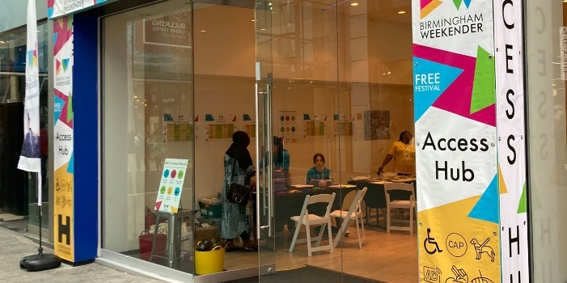

There are two other Access & Info Points – situated on Victoria Square

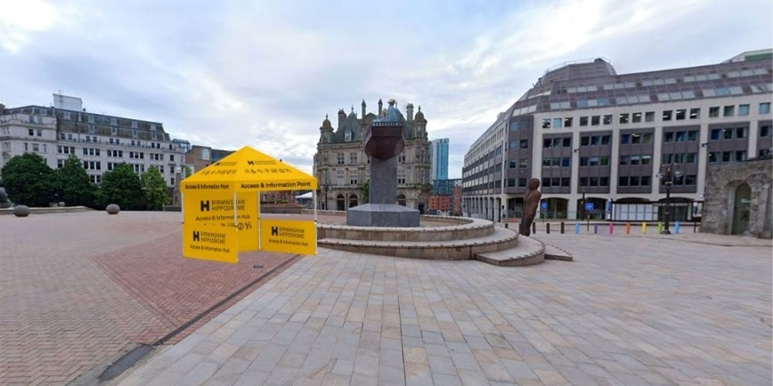

and Hippodrome Square.

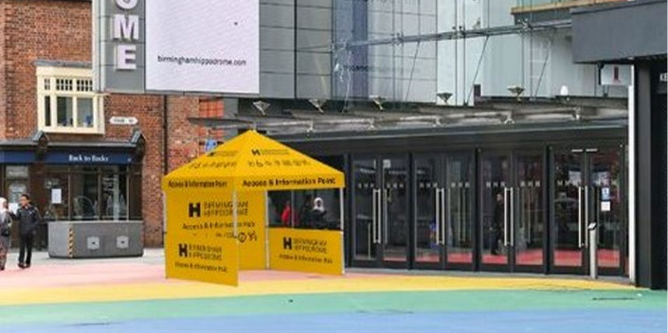

Please look out for our friendly access staff to help you. They will be wearing these lovely yellow T shirts.

and show you the quickest way to get there.

wheelchair you can use if you find that walking is just too much!

and a chill out space.

** that you can wear so that our staff all around festival will know if you need a little extra help as you may feel a bit anxious in the crowds.

PERFORMANCE TIMETABLES

These timetables tell you about what access performances are happening on each day.

**FRIDAY**

**SATURDAY**

|  |  |  |
| --- | --- | --- |
| **Accessible Viewing Points** | | |
| **Piece** | **Time(s)** | **Location** |
| Tread | 12:00 PM | Inside the Bullring (near M&S) |
| Unity | 12:00 PM | Rotunda Square |
| Comedy Club 4 Kids | 12:15 PM | St Martin's Square |
| Closer To My Dreams | 12:35 PM | Inside the Bullring (near M&S) |
| Performers College LUNA Inspired Dance | 1:00 PM | Inside the Bullring (near M&S) |
| Tape That | 1:00 PM | Inside New Street Station |
| SYNERGY | 1:15 PM | Inside the Bullring (M&S) |
| TEABREAK | 1:30 PM | Victoria Square |
| Swan Break | 1:40 PM | Inside the Bullring (near M&S) |
| Uplift | 2:05 PM | Inside the Bullring (near M&S) |
| Torch of Excellence | 2:30 PM | Inside New Street Station |
| Mughal Miniatures | 2:40 PM | 1000 Trades Square, New Street Station |
| Closer To My Dreams | 2:55 PM | Inside the Bullring (near M&S) |
| Performers College LUNA Inspired Dance | 3:20 PM | Inside the Bullring (near M&S) |
| Tread | 3:35 PM | Inside the Bullring (near M&S) |
| Mughal Miniatures | 3:45 PM | 1000 Trades Square, New Street Station |
| Uplift | 4:10 PM | Inside the Bullring (near M&S) |
| Mughal Miniatures | 4:30 PM | 1000 Trades Square, New Street Station |
| Swan Break | 4:35 PM | Inside the Bullring (near M&S) |
| SYNERGY | 5:00 PM | Inside the Bullring (near M&S) |
| Tape That | 5:00 PM | Inside New Street Station |
| Unity | 5:00 PM | Rotunda Square |
| Comedy Club 4 Kids | 5:15 PM | St Martin's Square |
| Torch of Excellence | 5:25 PM | Inside New Street Station |
| Closer To My Dreams | 5:40 PM | Inside the Bullring (near M&S) |

|  |  |  |
| --- | --- | --- |
| **Audio Description** | | |
| **Piece** | **Time(s)** | **Location** |
| Sound Garden | 12:00 PM | Edgbaston Street |
| SPARK Activity Zone | 12:00 PM | Edgbaston Street |
| The City That Spoke To Me | 12:00 PM | Inside New Street Station |
| Weekender Green Hub | 12:00 PM | Edgbaston Street |
| Comedy Club 4 Kids | 12:15 PM | St Martin's Square |
| TEABREAK | 1:30 PM | Victoria Square |
| Mughal Miniatures | 2:40 PM | 1000 Trades Square, New Street Station |
| Sound Garden | 3:00 PM | Edgbaston Street |
| SPARK Activity Zone | 3:00 PM | Edgbaston Street |
| Weekender Green Hub | 3:00 PM | Edgbaston Street |
| Performers College LUNA Inspired Dance | 3:20 PM | Inside the Bullring (near M&S) |
| Tread | 3:35 PM | Inside the Bullring (near M&S) |
| Mughal Miniatures | 3:45 PM | 1000 Trades Square, New Street Station |
| Uplift | 4:10 PM | Inside the Bullring (near M&S) |
| Mughal Miniatures | 4:30 PM | 1000 Trades Square, New Street Station |
| Swan Break | 4:35 PM | Inside the Bullring (near M&S) |
| SYNERGY | 5:00 PM | Inside the Bullring (near M&S) |
| Tape That | 5:00 PM | Inside New Street Station |
| Unity | 5:00 PM | Rotunda Square |
| Torch of Excellence | 5:25 PM | Inside New Street Station |
| Closer To My Dreams | 5:40 PM | Inside the Bullring (near M&S) |

|  |  |  |
| --- | --- | --- |
| **BSL Interpretation** | | |
| **Piece** | **Time(s)** | **Location** |
| Sound Garden | 12:00 PM | Edgbaston Street |
| SPARK Activity Zone | 12:00 PM | Edgbaston Street |
| Weekender Green Hub | 12:00 PM | Edgbaston Street |
| Comedy Club 4 Kids | 12:15 PM | St Martin's Square |
| SYNERGY | 1:15 PM | Inside the Bullring (near M&S) |
| TEABREAK | 1:30 PM | Victoria Square |
| Uplift | 2:05 PM | Inside the Bullring (near M&S) |
| Uplift | 4:10 PM | Inside the Bullring (near M&S) |
| SYNERGY | 5:00 PM | Inside the Bullring (near M&S) |
| Unity | 5:00 PM | Rotunda Square |

|  |  |  |
| --- | --- | --- |
| **Relaxed Sessions** | | |
| **Piece** | **Time(s)** | **Location** |
| Weekender Green Hub | 12:00 PM | Edgbaston Street |
| Luminarium | 12:00 PM | Victoria Square |
| Sound Garden | 12:00 PM | Edgbaston Street |
| SPARK Activity Zone | 12:00 PM | Edgbaston Street |
| Luminarium | 5:30 PM | Victoria Square |

**SUNDAY**

|  |  |  |
| --- | --- | --- |
| **Accessible Viewing Points** | | |
| **Piece** | **Time(s)** | **Location** |
| Tread | 12:00 PM | Inside the Bullring (near M&S) |
| Unity | 12:00 PM | Rotunda Square |
| Comedy Club 4 Kids | 12:15 PM | St Martin's Square |
| Closer To My Dreams | 12:35 PM | Inside the Bullring (near M&S) |
| Hippodrome Live! | 1:00 PM | Hippodrome Square |
| Tape That | 1:00 PM | Inside New Street Station |
| SYNERGY | 1:15 PM | Inside the Bullring (near M&S) |
| TEABREAK | 1:30 PM | Victoria Square |
| Swan Break | 1:40 PM | Inside the Bullring (near M&S) |
| Bamboo | 2:00 PM | 1000 Trades Square, New Street Station |
| Uplift | 2:05 PM | Inside the Bullring (near M&S) |
| Torch of Excellence | 2:30 PM | Inside New Street Station |
| Closer To My Dreams | 2:55 PM | Inside the Bullring (near M&S) |
| Hippodrome Live! | 3:30 PM | Hippodrome Square |
| Tread | 3:35 PM | Inside the Bullring (near M&S) |
| Uplift | 4:10 PM | Inside the Bullring (near M&S) |
| Bamboo | 4:15 PM | 1000 Trades Square, New Street Station |
| Swan Break | 4:35 PM | Inside the Bullring (near M&S) |
| SYNERGY | 5:00 PM | Inside the Bullring (near M&S) |
| Tape That | 5:00 PM | Inside New Street Station |
| Unity | 5:00 PM | Rotunda Square |
| Comedy Club 4 Kids | 5:15 PM | St Martin's Square |
| Torch of Excellence | 5:25 PM | Inside New Street Station |
| Closer To My Dreams | 5:40 PM | Inside the Bullring (near M&S) |

|  |  |  |
| --- | --- | --- |
| **Audio Description** | | |
| **Piece** | **Time(s)** | **Location** |
| Sound Garden | 12:00 PM | Edgbaston Street |
| SPARK Activity Zone | 12:00 PM | Edgbaston Street |
| The City That Spoke To Me | 12:00 PM | Inside New Street Station |
| Unity | 12:00 PM | Rotunda Square |
| Weekender Green Hub | 12:00 PM | Edgbaston Street |
| Hippodrome Live! | 1:00 PM | Hippodrome Square |
| TEABREAK | 1:30 PM | Victoria Square |
| Bamboo | 2:00 PM | 1000 Trades Square, New Street Station |
| Sound Garden | 3:00 PM | Edgbaston Street |
| SPARK Activity Zone | 3:00 PM | Edgbaston Street |
| Weekender Green Hub | 3:00 PM | Edgbaston Street |
| Tread | 3:35 PM | Inside the Bullring (near M&S) |
| Uplift | 4:10 PM | Inside the Bullring (near M&S) |
| Swan Break | 4:35 PM | Inside the Bullring (near M&S) |
| SYNERGY | 5:00 PM | Inside the Bullring (near M&S) |
| Tape That | 5:00 PM | Inside New Street Station |
| Comedy Club 4 Kids | 5:15 PM | St Martin's Square |
| Torch of Excellence | 5:25 PM | Inside New Street Station |
| Closer To My Dreams | 5:40 PM | Inside the Bullring (near M&S) |

|  |  |  |
| --- | --- | --- |
| **BSL Interpretation** | | |
| **Piece** | **Time(s)** | **Location** |
| Sound Garden | 12:00 PM | Edgbaston Street |
| Unity | 12:00 PM | Rotunda Square |
| Weekender Green Hub | 12:00 PM |  |
| SPARK Activity Zone | 12:00 PM | Edgbaston Street |
| Comedy Club 4 Kids | 12:15 PM | St Martin's Square |
| Hippodrome Live! | 1:00 PM | Hippodrome Square |
| SYNERGY | 1:15 PM | Inside the Bullring (near M&S) |
| TEABREAK | 1:30 PM | Victoria Square |
| Uplift | 2:05 PM | Inside the Bullring (near M&S) |
| Hippodrome Live! | 3:30 PM | Hippodrome Square |
| Uplift | 4:10 PM | Inside the Bullring (near M&S) |
| Unity | 5:00 PM | Rotunda Square |
| SYNERGY | 5:00 PM | Inside the Bullring (near M&S) |
| Comedy Club 4 Kids | 5:15 PM | St Martin's Square |

|  |  |  |
| --- | --- | --- |
| **Relaxed Performances** | | |
| **Piece** | **Time(s)** | **Location** |
| Luminarium | 12:00 PM | Victoria Square |
| Sound Garden | 12:00 PM | Edgbaston Street |
| SPARK Activity Zone | 12:00 PM | Edgbaston Street |
| Weekender Green Hub | 12:00 PM | Edgbaston Street |
| Blanko | 3:45 PM | Access Hub |
| Luminarium | 5:30 PM | Victoria Square |

**MONDAY**

|  |  |  |
| --- | --- | --- |
| **Accessible Viewing Points** | | |
| **Piece** | **Time(s)** | **Location** |
| CBSO in the City | 1:00 PM | Inside the Bullring (near M&S) |
| Tape That | 1:00 PM | Inside New Street Sation |
| TEABREAK | 1:30 PM | Victoria Square |
| Unity | 2:00 PM | Rotunda Square |
| CBSO in the City | 3:00 PM | Inside the Bullring (near M&S) |
| Tape That | 5:00 PM | Inside New Street Sation |

|  |  |  |
| --- | --- | --- |
| **Relaxed Performances** | | |
| **Piece** | **Time(s)** | **Location** |
| Luminarium | 12:00 PM | Victoria Square |
| Sound Garden | 12:00 PM | Edgbaston Street |
| Weekender Green Hub | 12:00 PM | Edgbaston Street |
| SPARK Activity Zone | 12:00 PM | Edgbaston Street |
| Blanko | 3:45 PM | Access Hub |
| Luminarium | 5:30 PM | Victoria Square |

