Marble Awareness Roadshow

United Nations Board of
Significant Inspiration



Time   | 12 noon - 6pm  But you can come and go as you please.
Who is it for?   | All ages, particularly neurodivergent audiences.
Where is it?   | Bullring and Grand Central – Central Street  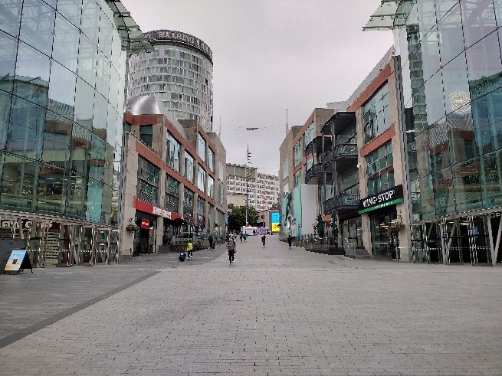
Access   |   This piece does contain text and speech, but it is not needed to understand the story.    There is no music.  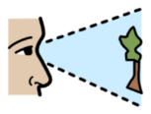  The piece moderately relies on visuals.  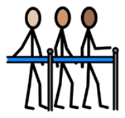  There will be a queue system in place.    Please find an Access Host in a yellow t-shirt for assistance if you would like to avoid queues.  The nearest Access Hub is on Rotunda Square.  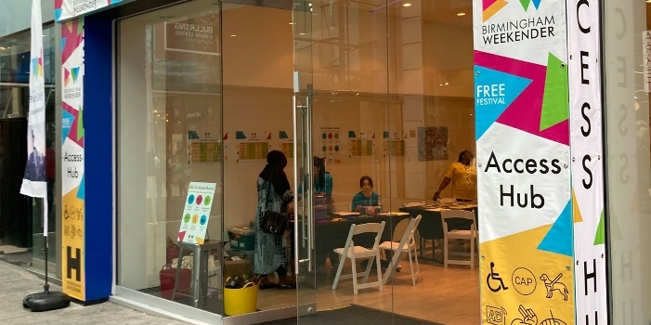
Content warnings   |   Marble runs may be constructed above head height and any participants will be required to wear hard-hats.    The piece is interactive.
Main themes   |   Theatre    Environmental    Scientific

What will happen during the performance?
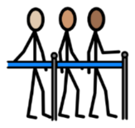


Queue in a line





Discover the science of Marbleology



Watch a Marble Experience Exposure Machine




Build marble runs

Find out more

https://www.birminghamhippodrome.com/calendar/unbosi-marble-awareness-roadshow/

Website link: https://www.unbosi.org/marble-awareness-roadshow/
Instagram: https://www.instagram.com/unbosimarbles/
Facebook: https://www.facebook.com/unbosimarbles
X: https://x.com/unbosimarbles

Contact us

charlotteboyer@birminghamhippodrome.com

