Mughal Miniatures

Sonia Sabri Company

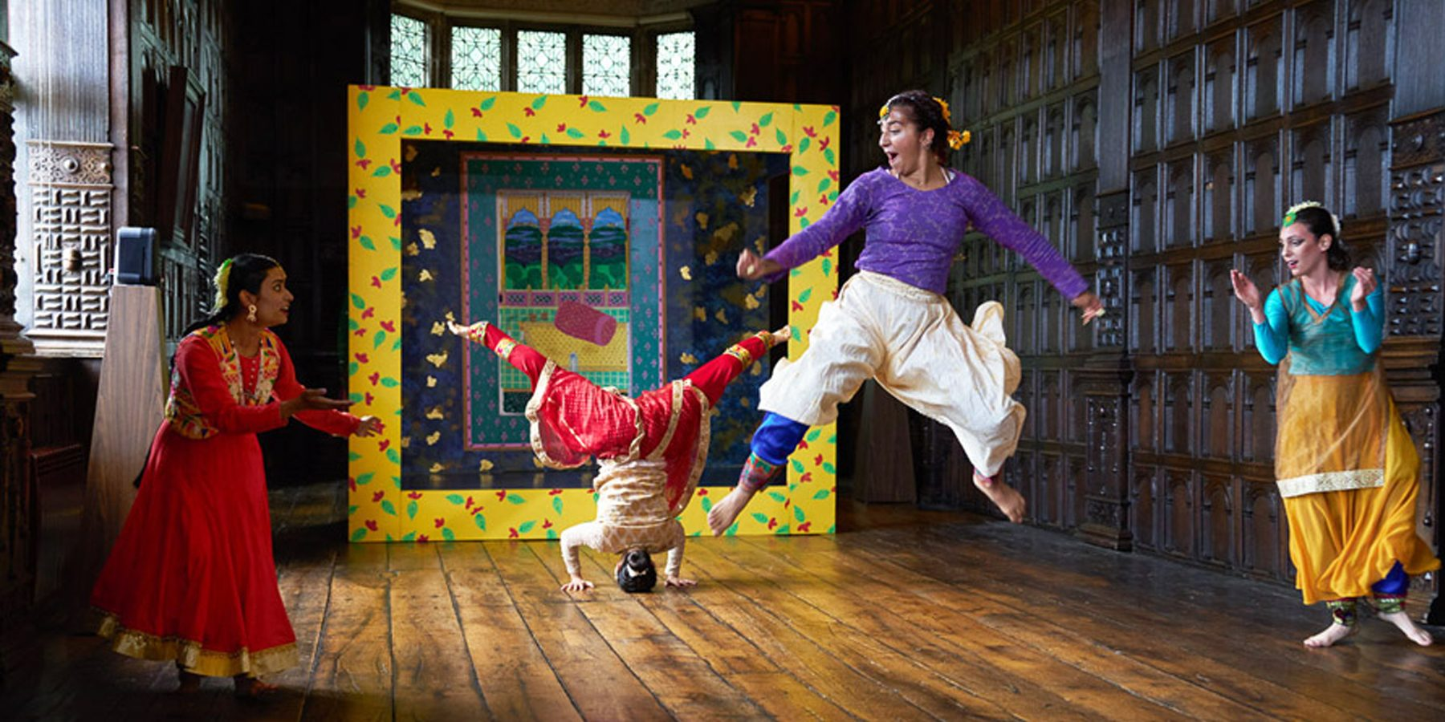

Time   | 12 noon - 6pm  But you can come and go as you please.
Who is it for?   | All ages, particularly families.
Where is it?   | 1000 Trades Square, New Street Station  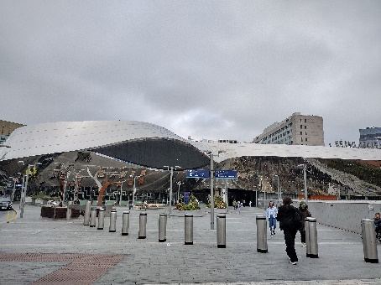
Access   |       This performance will be Audio Described and will have an Accessible Viewpoint on Saturday 24th August at 2:40pm and 3:40pm.    This piece does not contain text or speech.  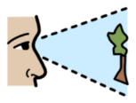  The piece moderately relies on visuals.    Please find an Access Host in a yellow t-shirt for further assistance.  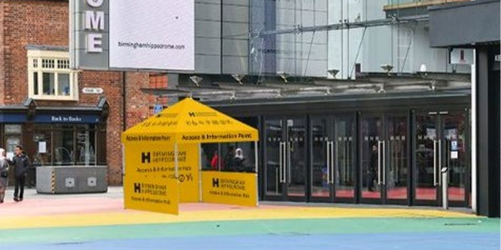  The nearest Access & Info Point is on Hippodrome Square.
Content warnings   |   Some parts may be interactive.      There will be loud music.
Main themes   |   Dance    Puppetry  Music    Comedy

What will happen during the performance?
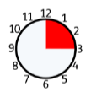

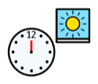

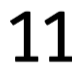

There are eleven performances from 12 noon to 6pm with 15-minute



breaks in between each one.




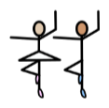
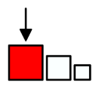

You will see dancers and people dressed as big puppets.






They will dance in an Indian garden with cushions, music and

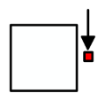

miniature painting artwork.


Some parts will be funny.
There will be laughter from the audience.

Find out more

https://www.birminghamhippodrome.com/calendar/mughal-miniatures/#performance_content

Website link: https://www.ssco.org.uk/
Instagram: https://www.instagram.com/soniasabrico/
Facebook: https://www.facebook.com/soniasabricompany/
X: https://x.com/SoniaSabriCo
TikTok: https://www.tiktok.com/@soniasabrico
LinkedIn: https://www.linkedin.com/company/sonia-sabri-company/
Youtube: https://www.youtube.com/@soniasabricompany/

Contact us

charlotteboyer@birminghamhippodrome.com

