OakMobile

By

Talking Birds

Saturday 24th – Monday 26th August

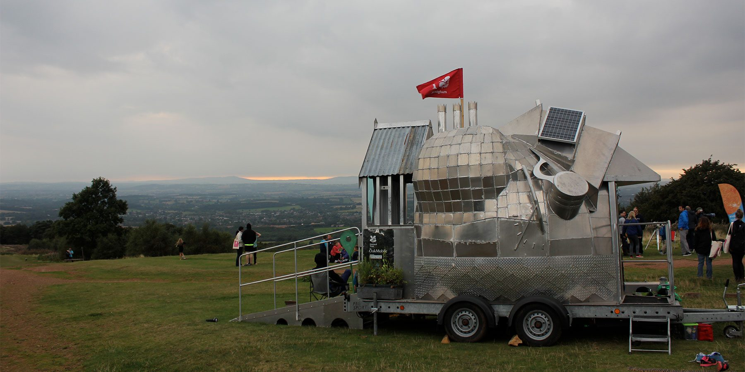

|  |  |
| --- | --- |
| Time | 12 noon – 2:30pm  &  3:30 – 6pm  You can come and go as you please. |
| Who is it for? | All ages. |
| Where is it? | Chaophraya Square |
| Access | This performance will contain speech.    It moderately relies on visuals.    It is wheelchair accessible.    Please find an Access Host in a yellow t-shirt for further assistance.  The nearest Access Hub is at Rotunda Square. |
| Content warnings | Some parts will be interactive.    There is an enclosed, multi-sensory space that you may enter. |
| Main themes | Theatre  A drawing of a landscape  Description automatically generated  Nature |

What will happen during the performance?

You will enter a dome-shaped machine.

There will be lots to see, touch, smell, and hear.

You will listen to a story about seasons and nature.

Some bits will be funny. You will hear people laughing.

Find out more

<https://www.birminghamhippodrome.com/calendar/oakmobile/#performance_content>

Website Link: <https://talkingbirds.co.uk/portfolio/work-outdoors/>

Instagram: <https://www.instagram.com/birdmail/>

Facebook: <https://www.facebook.com/TalkingBirds/>

X: <https://x.com/birdmail>

Contact us

[charlotteboyer@birminghamhippodrome.com](mailto:charlotteboyer@birminghamhippodrome.com)

