SPARK Activity Zone

By

Glue Collective

Saturday 24th – Monday 26th August

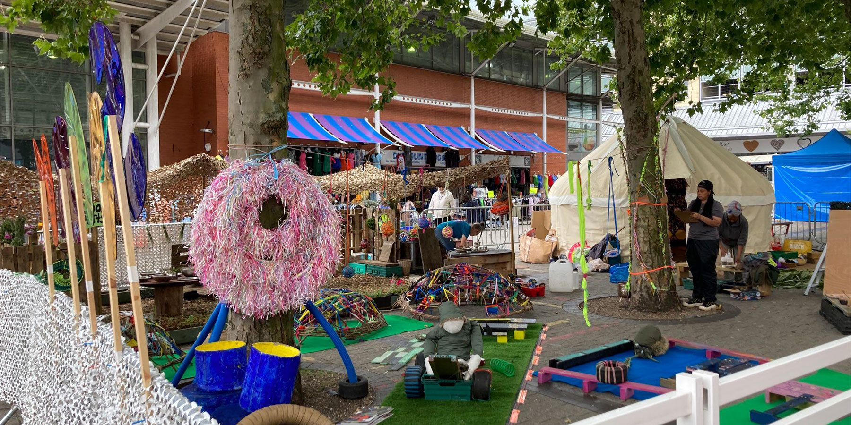

|  |  |
| --- | --- |
| Time | 12 noon – 6pm  But come and go as you please. |
| Who is it for? | All ages. |
| Where is it? | Edgbaston Street |
| Access | Events with Access Features | Camden People's Theatre  Relaxed sessions are from 12-1pm & 3-4pm each day.  Audio Description - Screen Machine  British Sign Language Interpretation and Audio Description is available for the Sat 24th & Sun 25th relaxed sessions.    This does not rely on text or speech.    It moderately relies on visuals.    Please find an Access Host in a yellow t-shirt for further assistance.  The nearest Access & Info Point is on Hippodrome Square.  Access & Info Point - Hippodrome Square. Weekender Festival image. A small yellow tent on the rainbow square outside the Hippodrome. |
| Content warnings | This is an interactive piece.    There will be soil and clay.    There may be crowds of people.    It may be loud. |
| Main themes | A drawing of a landscape  Description automatically generated  Environment    Sustainability |

What will happen during the performance?

There will be lots of different, interactive zones.

You can:

Play

Use the mud kitchen

Go into the yurt

See nature art installations made with natural materials

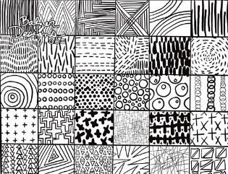

Do mark making and play with clay

Create your own paint using natural material

Find out more

<https://www.birminghamhippodrome.com/calendar/spark-activity-zone/>

Website Link: <https://www.gluecollective.co.uk/>

Instagram: <https://www.instagram.com/gluecollective/>

Contact us

[charlotteboyer@birminghamhippodrome.com](mailto:charlotteboyer@birminghamhippodrome.com)

