Birmingham Weekender Selfie Studio

By

Pickle Illustration

Friday 23rd – Monday 26th August

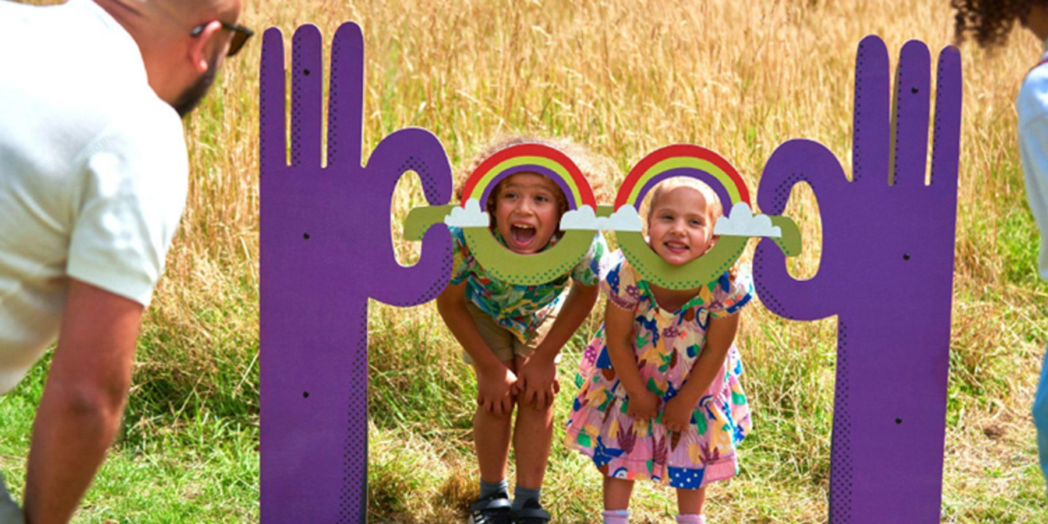

Time  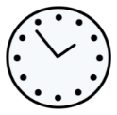 | 12 noon – 6pm  But come and go as you please.
Who is it for?  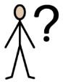 | All ages.
Where is it?  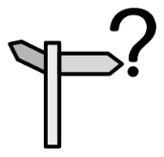 | Lower Mall East at Bullring & Grand Central  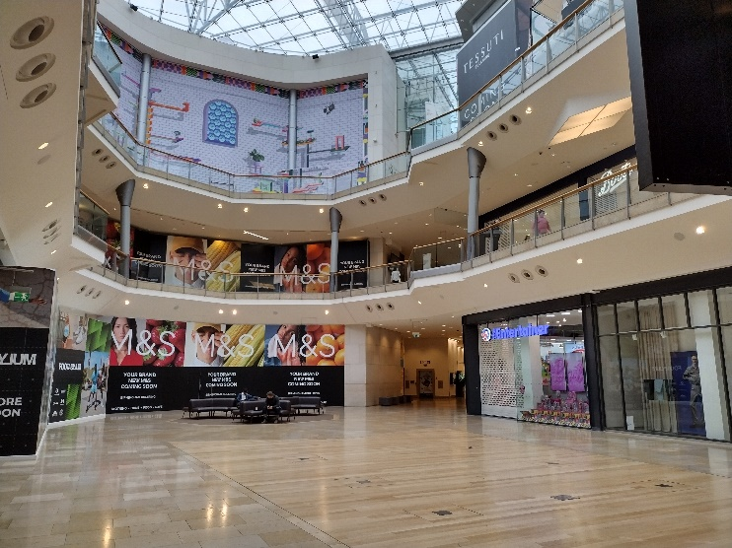
Access  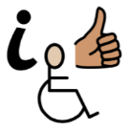 | 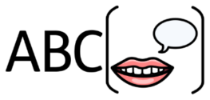  This does not rely on text or speech.  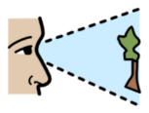  It moderately relies on visuals.    There is no music or sound effects.  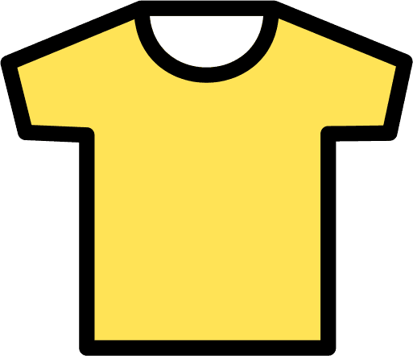  Please find an Access Host in a yellow t-shirt for further assistance.  The nearest Access Hub is at Rotunda Square.  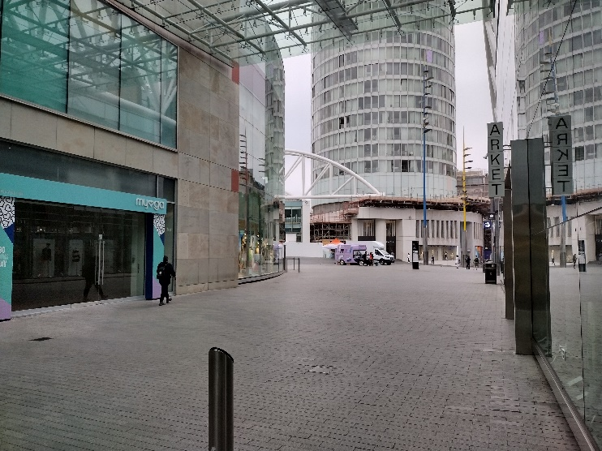
Content warnings   |   People will be taking pictures.  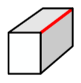  There may be sharp edges.  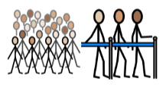  There may be crowds and queues to take pictures.    It may be loud in the Bullring.
Main themes   | Pictures  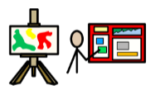  Art Exhibition

What will happen during the performance?

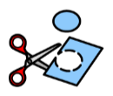

You will see art displays with cutouts.

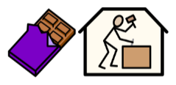
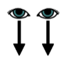
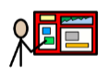

Some of the displays will look like a chocolate factory,

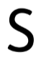
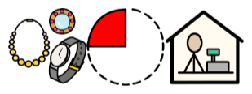
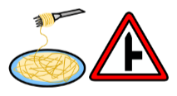

spaghetti junction, a jewellery quarter shop, and Selfridges.



You can touch the cutouts.

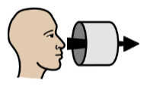

You can put your head through some of the cutouts and

take pictures with them.

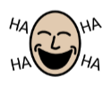

Some bits will be funny. You will hear people laughing.

Find out more

https://www.birminghamhippodrome.com/calendar/birmingham-weekender-selfie-studio/#performance_content

Website Link: https://www.pickleillustration.com/
Instagram: https://www.instagram.com/pickleillustration/

Contact us

charlotteboyer@birminghamhippodrome.com

