The Luminarium

By

Architects of Air
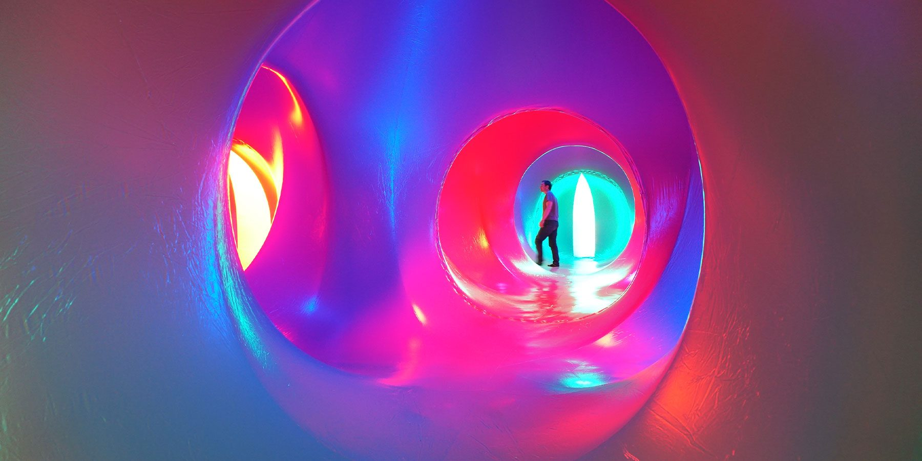

Time   | 12pm-6pm  You need to book a timed slot here
Who is it for?   | Everyone!
Where is it?   | Victoria Square  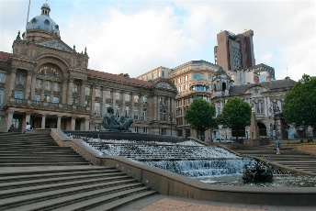
Access   |   There will be relaxed sessions on Saturday 24^{th,} Sunday 25th and Monday 26th at 12pm-12:30pm and 5:30pm-6pm.  The nearest Access Point is on Victoria Square  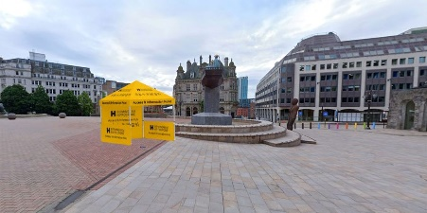
Content warnings   |   The space might make you feel a little bit dizzy
  Main themes |   Sensory  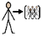  Immersive experience    Colours    Calm

What will happen during the experience?

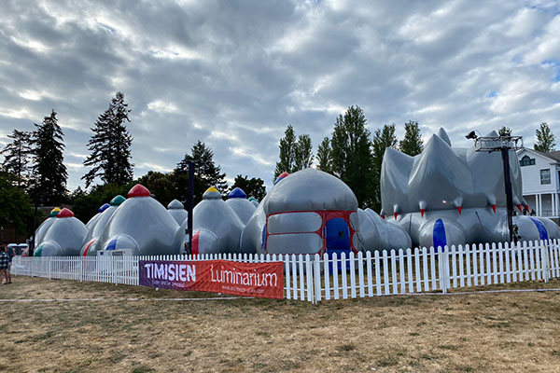
The Luminarium looks like this on the outside

The Luminarium looks like this on the inside
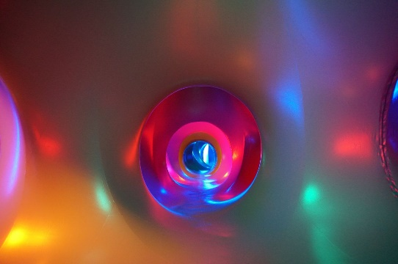
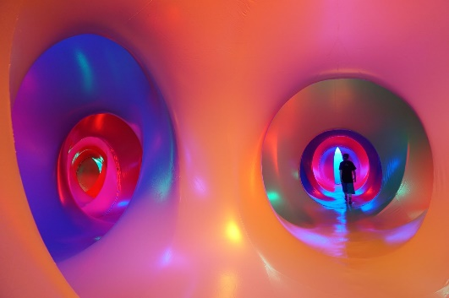

You will…

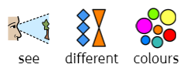

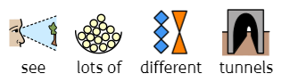
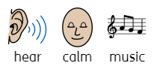

In the relaxed session there will be
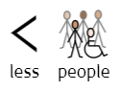

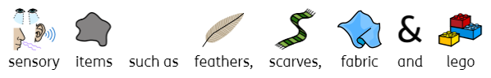
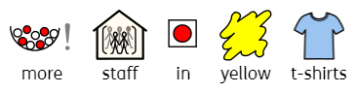

Find out more
https://www.birminghamhippodrome.com/calendar/luminarium-2/

Website www.architects-of-air.com
Facebook www.facebook.com/pages/Architects-of-Air/100555823335741
Instagram https://www.instagram.com/architects_of_air/
Online videos www.architects-of-air.com/media.html
The Book www.architects-of-air.com/the-aoa-book.html

Contact us
charlotteboyer@brimingahmhippodrome.com



