Unity

By

Gorilla Circus

Saturday 24th & Sunday 25th August 12pm & 5pm

Monday 26th August 2pm

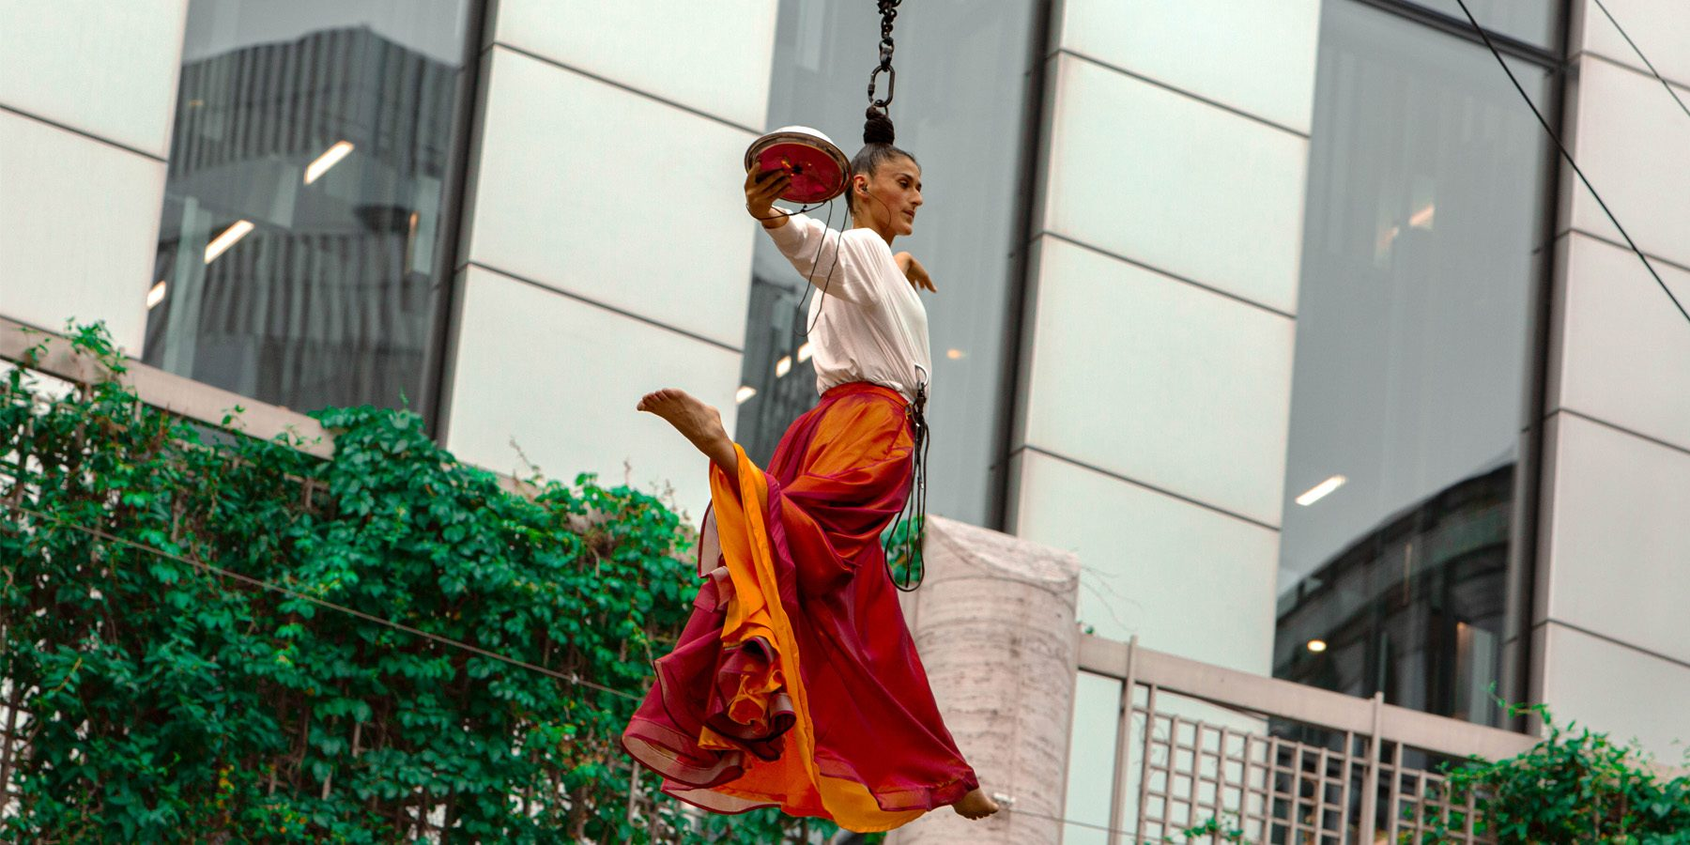

Time   | 35 mins  But you can come and go when you please
Who is it for?   | Everyone!
Where is it?   | 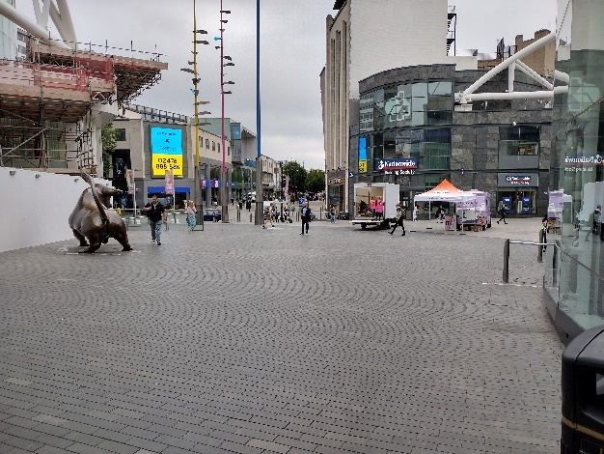  Rotunda Square
Access   | There will be an accessible viewpoint for all performances.  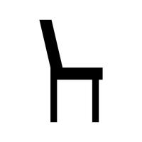        BSL and Audio Description will be available on Saturday 24th August at 5pm and Sunday 25th Auguust at 12pm.
Content warnings   | There will be thick smoke, and haze used in the performance.
  Main themes |   Circus    Storytelling  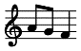  Music    Poetry

What will happen during the performance?
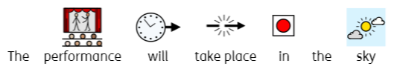

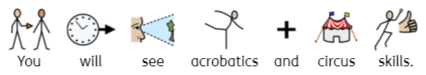

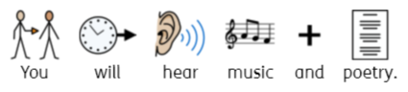

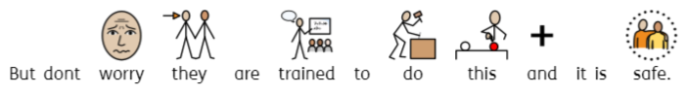
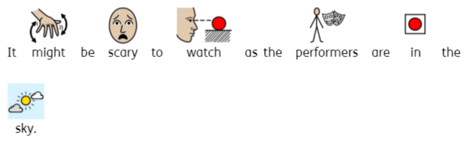

Find out more
https://www.birminghamhippodrome.com/calendar/unity/

https://www.instagram.com/gorillacircusproduction/

Contact us
charlotteboyer@briminghamhippodrome.com

