Swan Lake Visual Guide

  - INTRODUCTION

This visual guide is designed for any audience members who want to familiarise themselves with what to expect from Swan Lake before they get to the theatre. The story is told entirely through dance and music with no speech, so this guide should help you follow the along.

It contains images and information about the characters, story and the production in general. We hope this resource makes your visit more enjoyable.
If you have any comments, please get in touch at office@new-adventures.net.

  - SHOW NOTES
Themes within the show
- Family, Power, Desire, Jealousy, Hope, Duty, Loss, Acceptance
Please be aware
- Swan Lake is approximately 2.5 hours long, including a 20-minute interval.
- The age guidance for this show is 5+
- The dancers playing the characters in this guide may not be the same dancers on the day you see the show, but the character costumes will be the same.
- The audience will clap during the show, for example when a big scene ends. You can join in if you want to.
Trigger Warnings
- Trigger warnings and sound warnings are in The Story section of this guide.
- A prop gun is used the second half. It does go off.
- Unsettling masks are used in the second half.
- There are set pieces, lighting effects and music which create a sinister or intense atmosphere, particularly when The Swans are on stage together.
  - MEET THE CHARACTERS
- The Prince – The Prince is very lonely and struggles with the duties of his role. He has a very troubled relationship with his mother, The Queen.
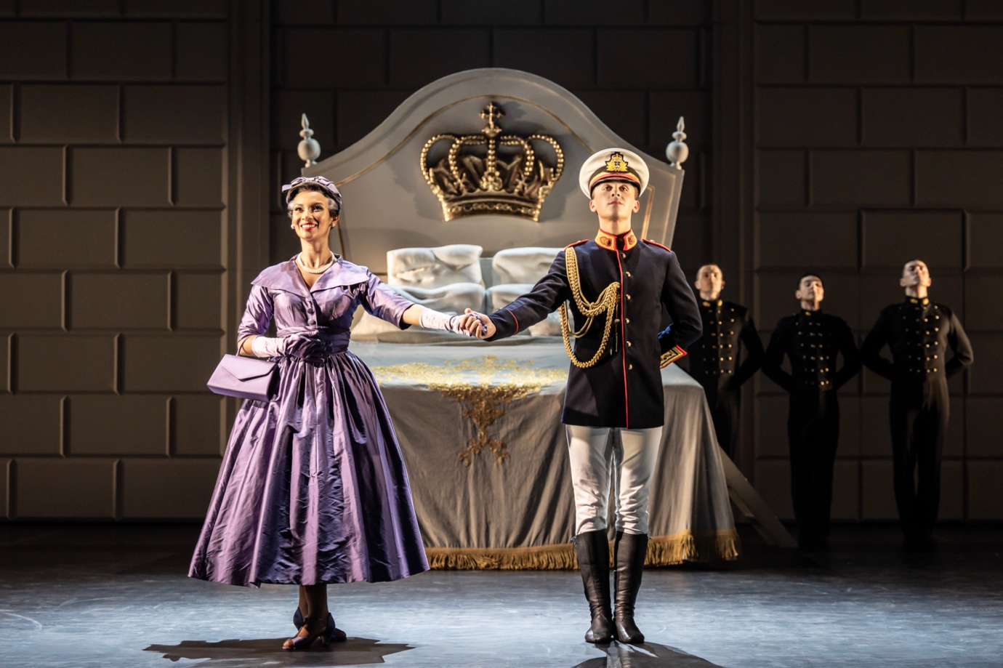
- The Swan and The Stranger – The Swan appears as a representation of everything that The Price desires in Act Two and introduces The Prince to a new world of possibility. The Stranger appears in Act Three, performed by the same dancer, now dressed as a human. But it seems like he doesn’t know The Prince.
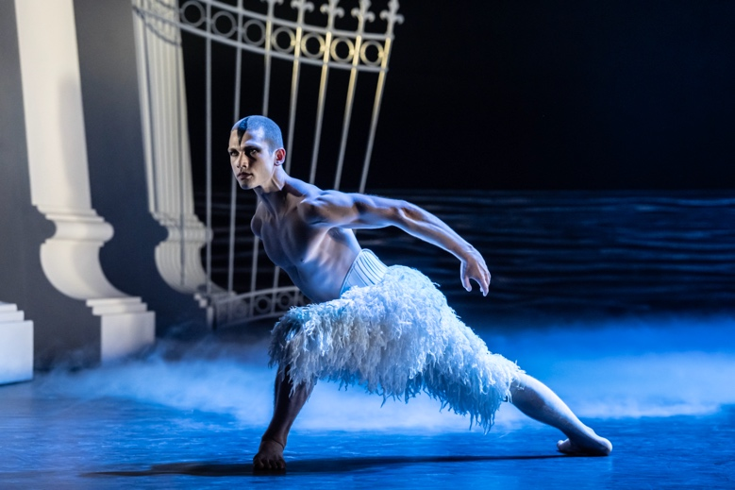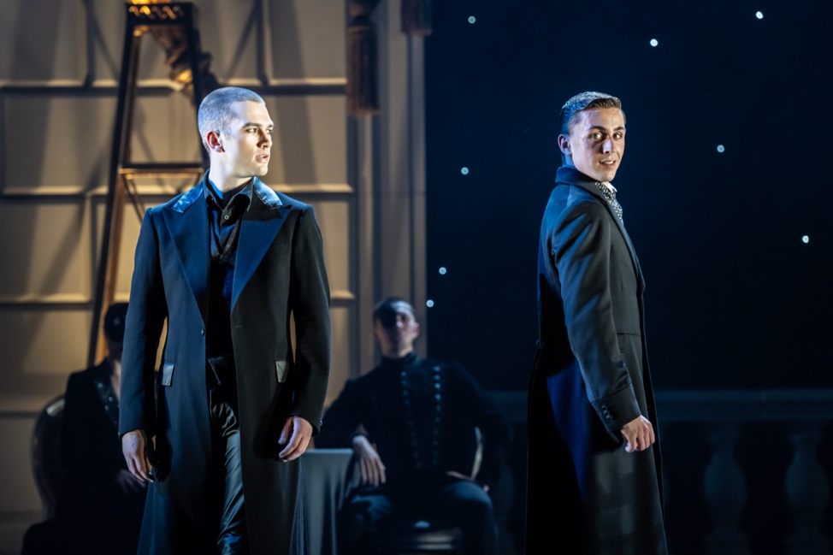
- The Queen – The Queen is stern, commanding and dutiful. She is usually distant towards The Prince and pays more attention to everyone else.
- The Private Secretary – The Private Secretary is manipulative and adds to the pressure The Prince feels. He is uptight and tense. 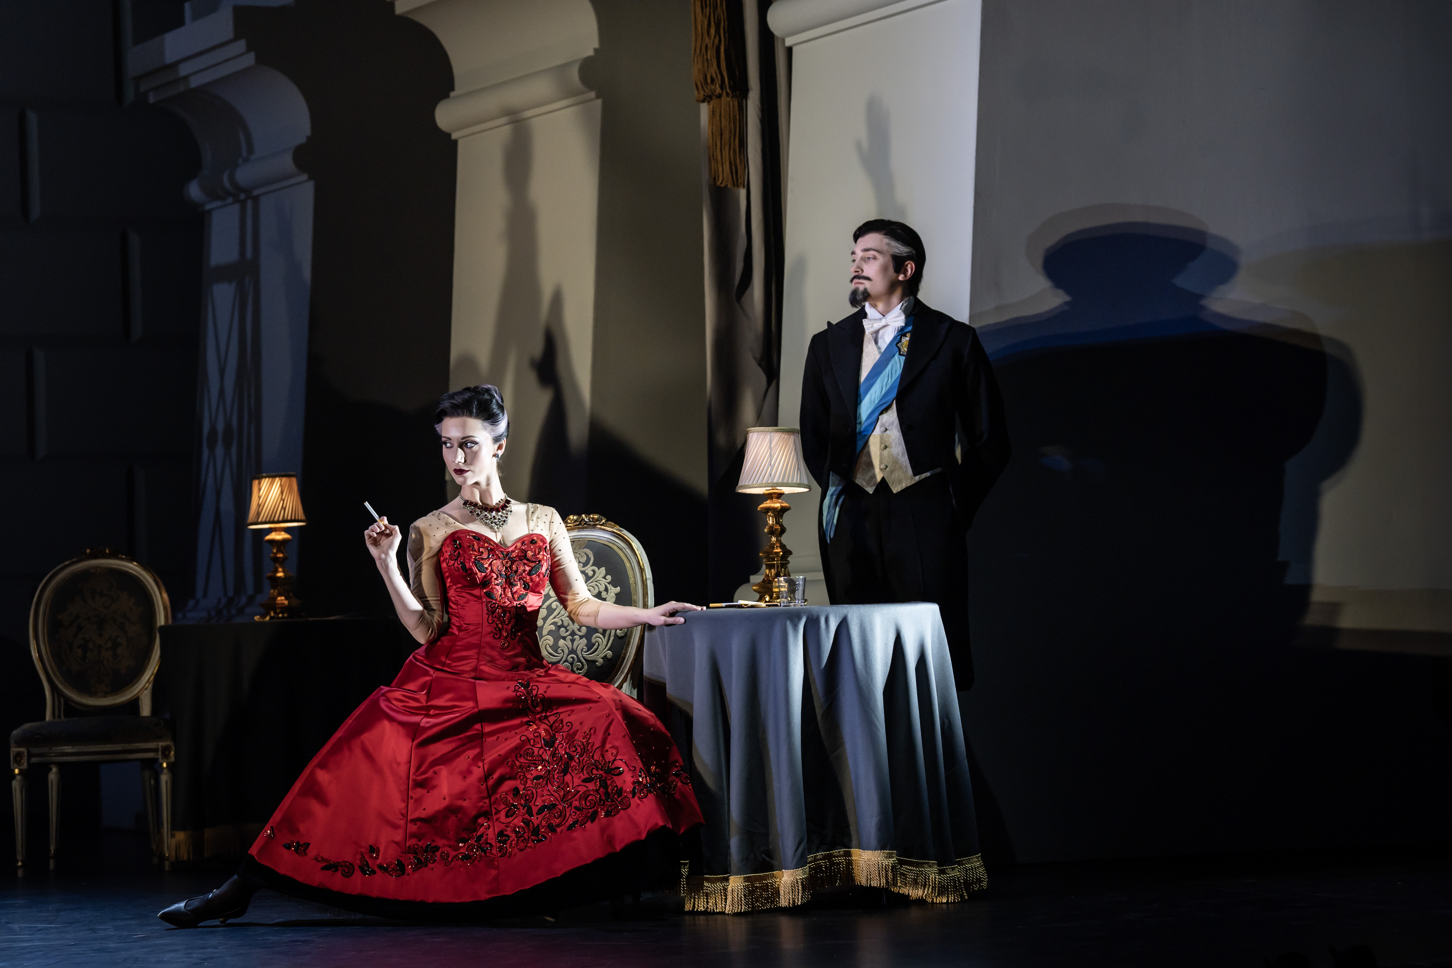
- The Girlfriend – The Prince’s Girlfriend is deemed a poor match for him because she lacks social etiquette and class. But she is positive and determined even in the face of harsh judgement, and brings some comedic relief.
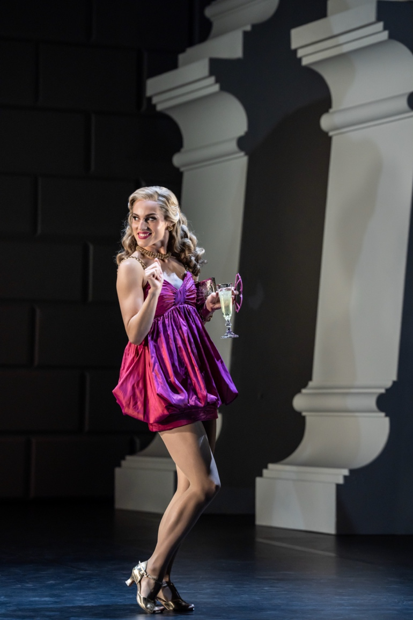
- The Swans – The flock of Swans appear in Act Two and Act Four. They can be both beautiful and menacing and are protective of their own.
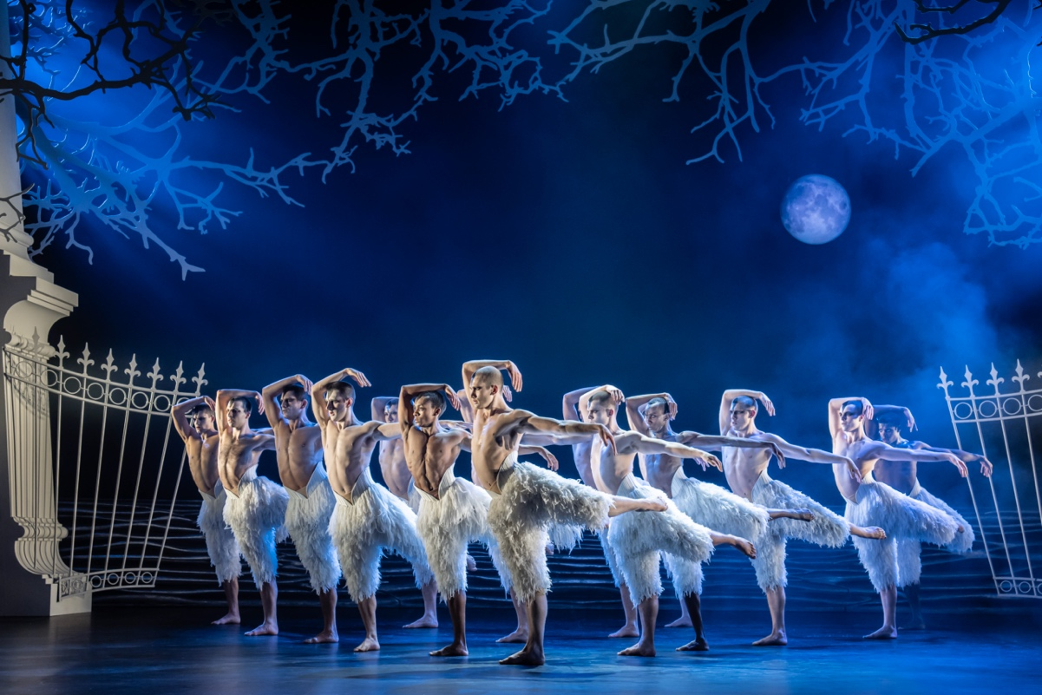

  - THE STORY
Scene 1 - The Prince’s Bedroom
Silhouetted swans fly in a projection on stage. As the music grows more sinister the stage lights reveal a giant bed with a royal crest on the headboard. The Prince is having a nightmare in bed while The Swan flaps his arms above him menacingly. The Prince jolts awake, and The Queen enters his room to check his temperature. She leaves swiftly, leaving him sad.
Trumpets herald the start of a new day at the palace. Soon The Prince’s bedroom is full of attendants who get him ready for royal duties. 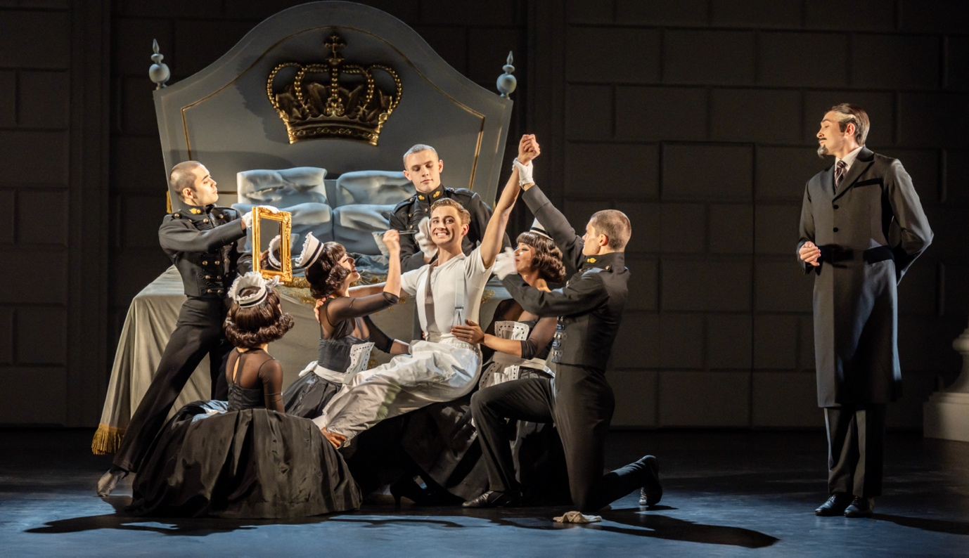
Scene 2 – The Palace
The Prince and The Queen wave to the public and undertake neatly executed obligations including ship launches and statue unveilings. The Prince appears disinterested but is kept on his toes by the supervision of his Private Secretary. The Girlfriend enters the palace, dressed in a short, pink dress. She hovers around The Prince until he takes notice, while The Queen clearly does not approve. With royal duties completed, The Queen departs with one of her male servants. The Prince and The Girlfriend leave together.
TRIGGER WARNING: Flashing lights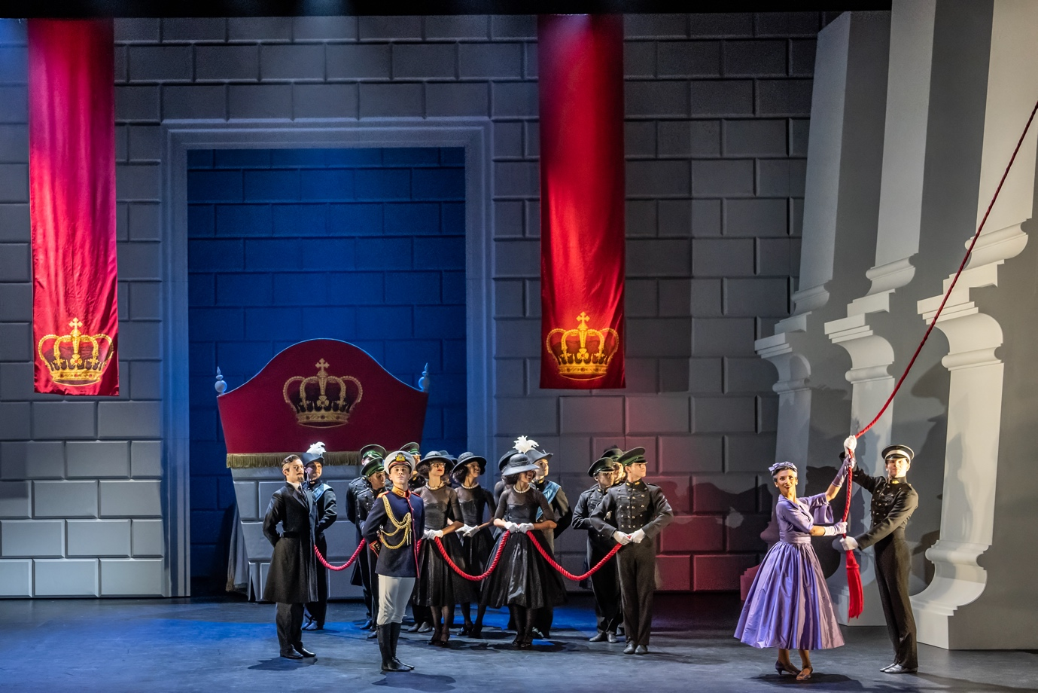
Scene 3 – At The Ballet
The curtains rise to reveal a stage within a stage. To the left sits a royal box, filled with The Queen and her male servant, The Prince and his Unsuitable Girlfriend; and the Private Secretary – all of whom have come to watch a ballet. As the ballet starts, The Girlfriend is fidgety and loud, annoying those around her. As the drama of the ballet heightens, so does The Queen’s disdain. During the final moments of the ballet, The Girlfriend drops her handbag onto the stage. This is the final straw for The Queen who leaves with her entourage, The Prince included, before the ballet performers take their bows.
TRIGGER WARNING: Prop axe. Scary masks that look like creatures made of trees.
SOUND WARNING: Flash, bang and smoke as a character appears on stage. Mobile phone goes off on stage.
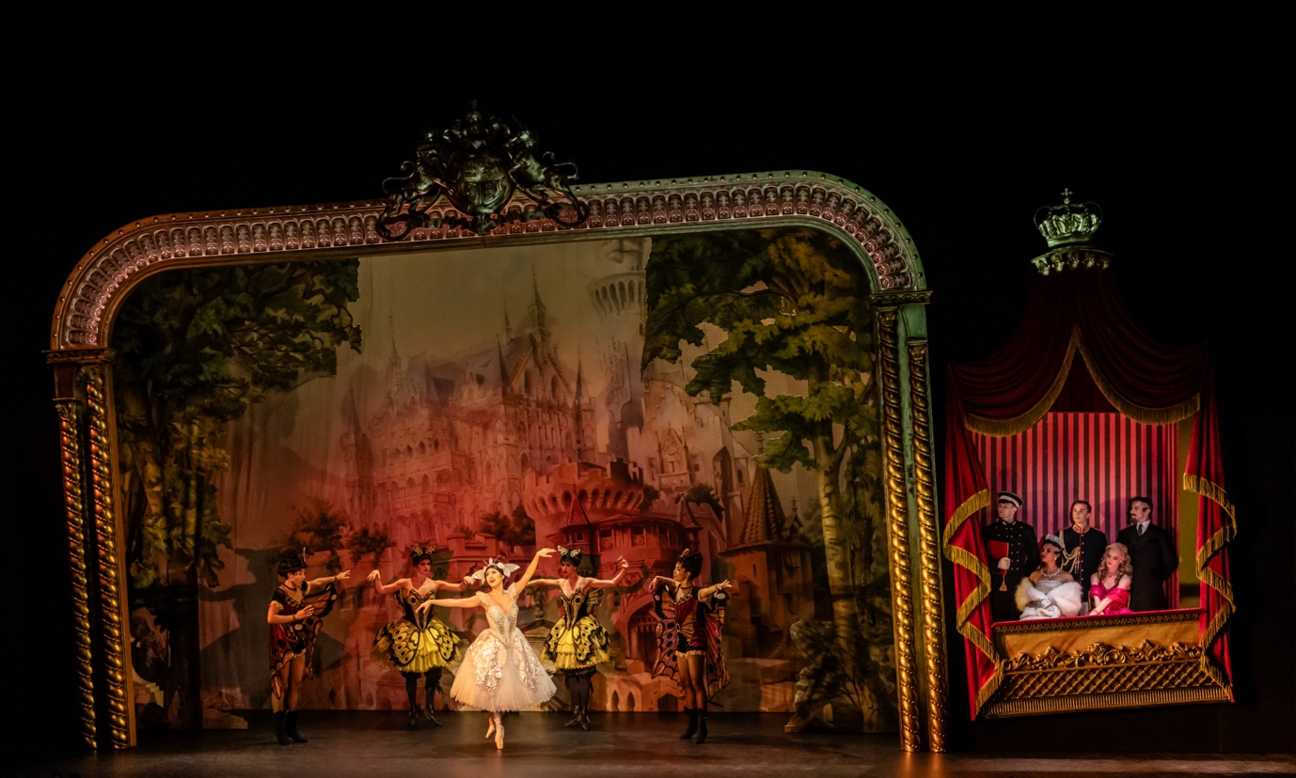
Scene 4 – The Prince’s Private Quarters
The Prince stands in front of a large mirror. Looking downbeat, he picks up a bottle of alcohol and takes a long swig. The Queen enters and The Prince rushes to her side, but no warmth is offered. Noticing the bottle The Queen scolds him. The Prince struggles desperately for physical affection and grows angry as The Queen keeps refusing. Eventually, The Queen exits, leaving The Prince alone again.
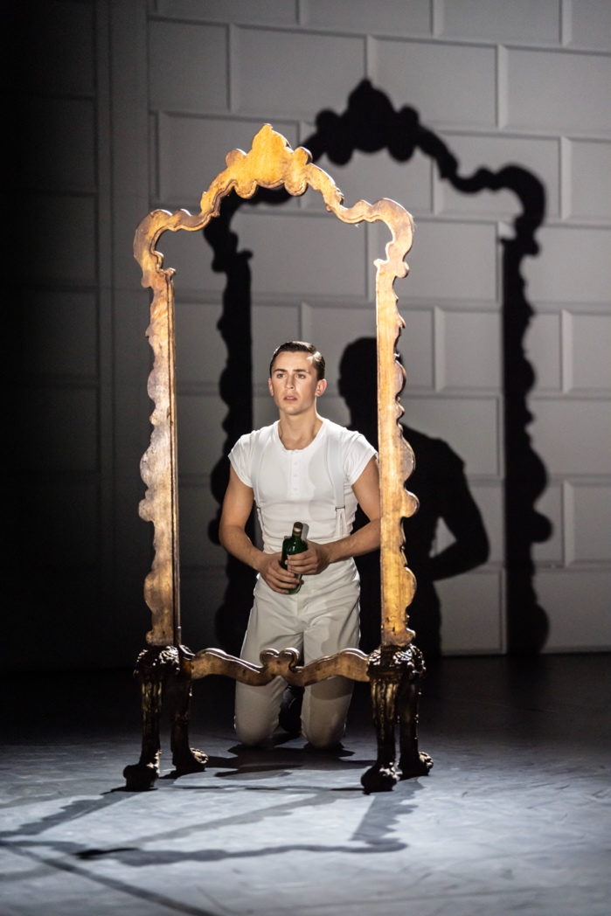
Scene 5 – The Street
The Girlfriend arrives to a club on the arm of a man in a suit. As they approach the bar the door swings open and the club owner in a gold jacket charges them entry. The door shuts behind them and through the ‘windows’ we see a small stage, flashing disco lights, and people dancing. Following, just moments behind, is The Prince, wearing a trench coat and trying to hide a bottle of alcohol.
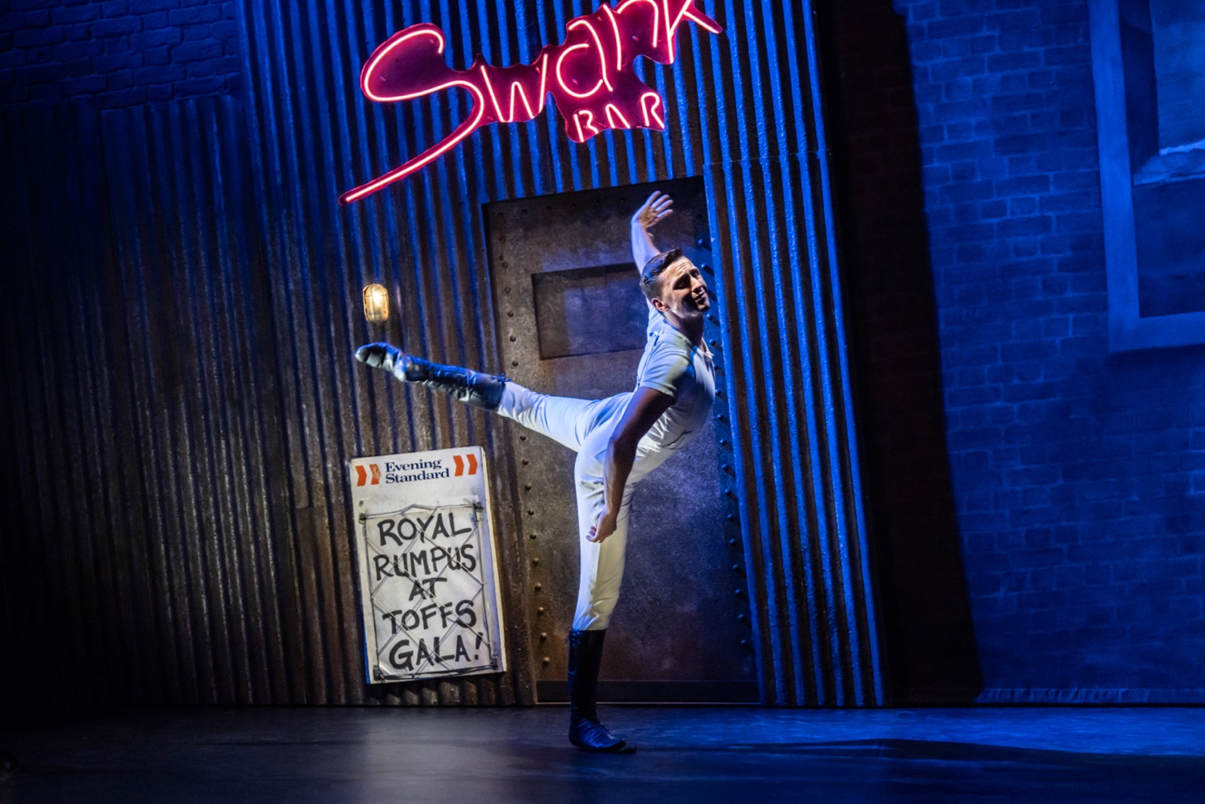
Scene 6 – A Seedy Club
Spotting his girlfriend dancing with another man, The Prince tries to entice her away but she’s clearly cross after he left her at the ballet. As The Prince watches on in frustration, someone in a coat and dark glasses - the Private Secretary in disguise – takes a seat next to him. As people dance, The Prince keeps drinking and getting more frustrated. A scuffle breaks out and The Prince is thrown out onto the street, where awaiting press photographers capture his fall from grace.
SOUND WARNING: Fast, rowdy and loud music in the club.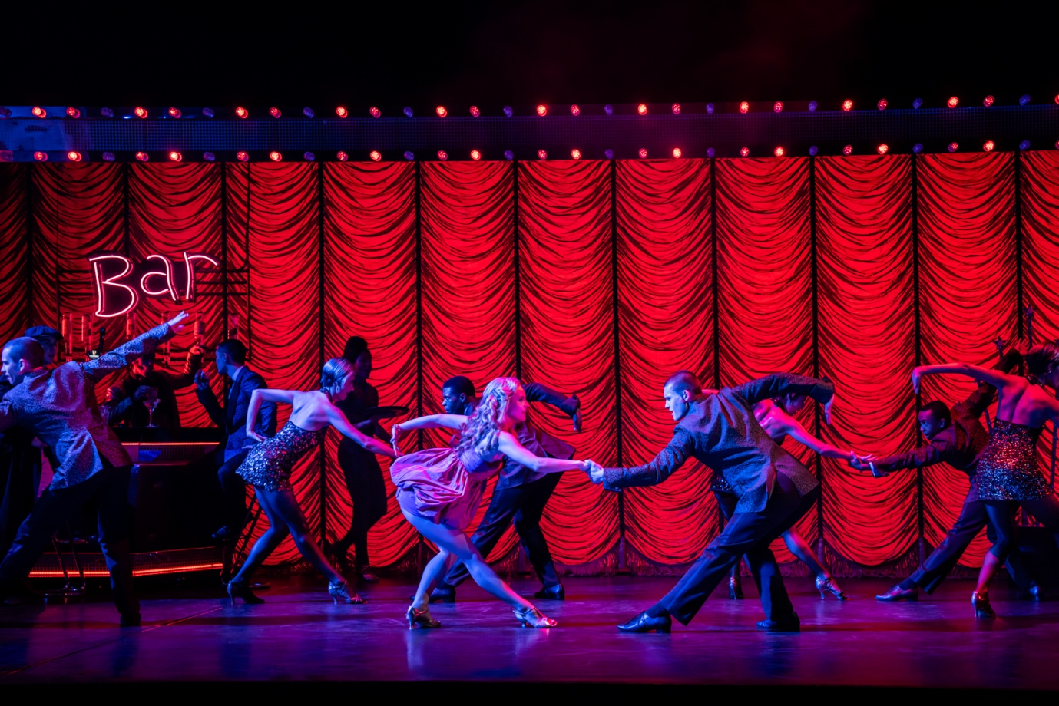
Scene 7 – The Street
Clearly worse for wear from hours of hard drinking, The Prince staggers before the club’s remaining clientele begin to make their way home. Couples stumble past with arms draped around waists; and The Prince strikes a lonesome figure. As the club door swings opens once more, out steps The Girlfriend and the Private Secretary. He shakes her hand and presses a handful of cash into it, which she tries unsuccessfully to give back. With head in hands, The Prince paces back and forth. Suddenly, he looks up to see an image of a swan taking flight and he sets off to follow it.
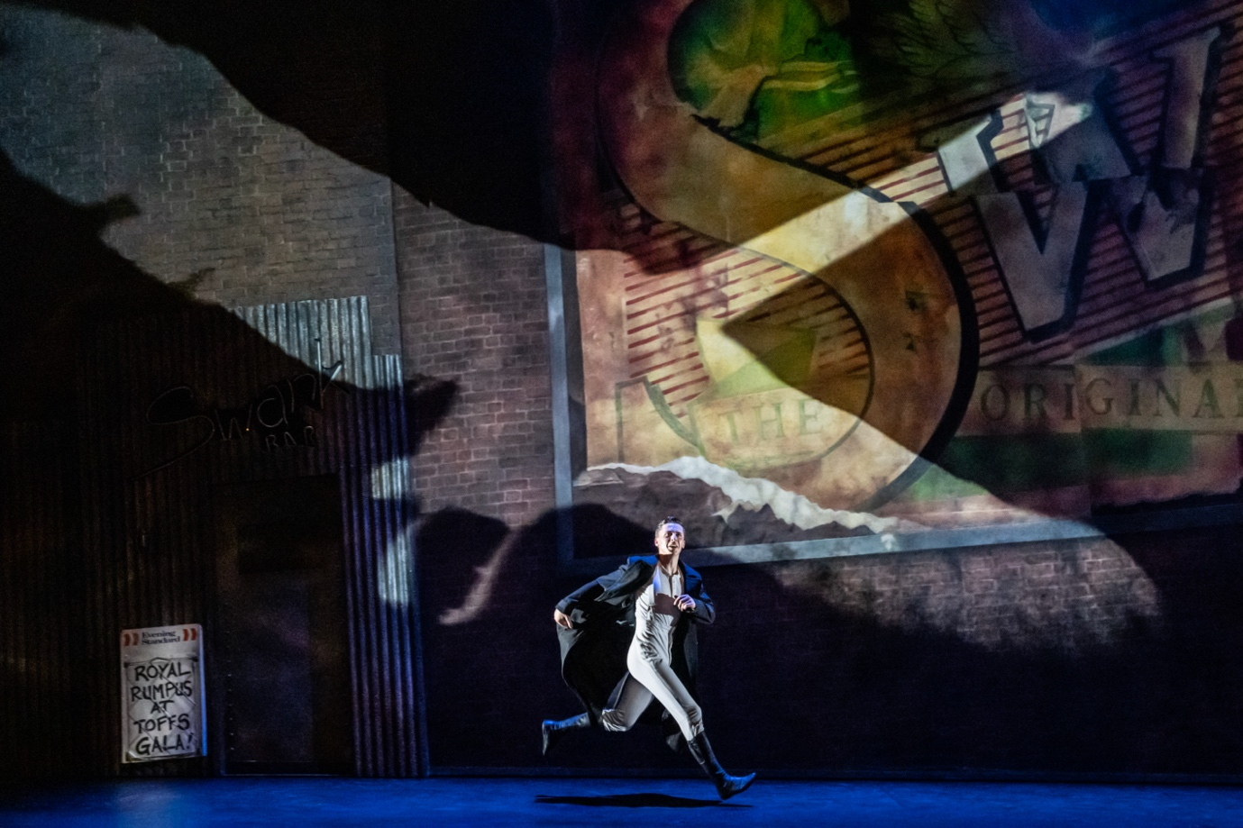
Scene 8 – The Lake
It’s still night-time as The Prince enters a park. He finds a piece of paper from a bin and scrawls a brief message and pins it to a lamppost. Arms outstretched, The Prince makes for the lake with urgency. Suddenly, he is stopped by the appearance of The Swan; who blocks his way. The Swan entrances The Prince and they tentatively dance together.

A flock of Swans appear on stage, captivating and powerful. They accept The Prince into their fold. The dancing builds to a climax before all the Swans disappear - leaving The Prince alone at the edge of the lake. Giddy with excitement, The Prince rushes off.

SOUND WARNING: 15 seconds of intense quietness when The Prince watches The Swan. Section ends with loud triumphant music. 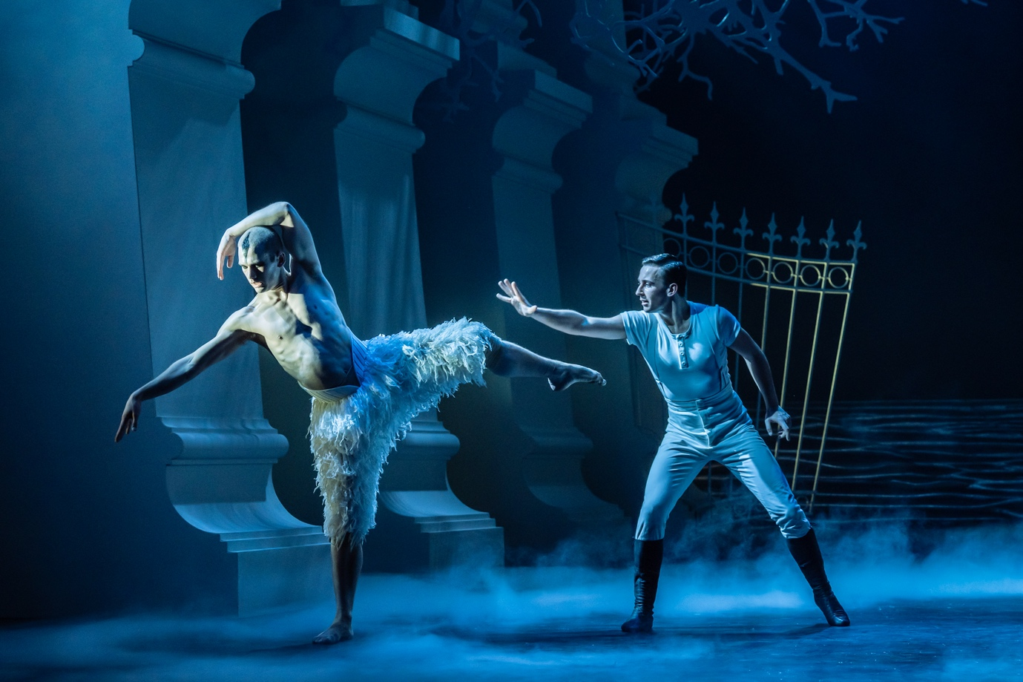

  - INTERVAL
The interval will be 20 minutes. The audience will clap and maybe cheer at the start of the interval.
You can stay in your seat or leave the auditorium. You might want to buy a drink or snack or use the toilet in the interval.

Scene 9 – The Palace Gates
In front of the palace gates is a throng of royal fans, held back by a rope. As a series of royals from different countries arrive for a special occasion, the onlookers cheer, wave and take photos. The Girlfriend is among them and as she enters she takes the Private Secretary aside and pushes the cash he gave her back into his hand.
TRIGGER WARNING: Flashing lights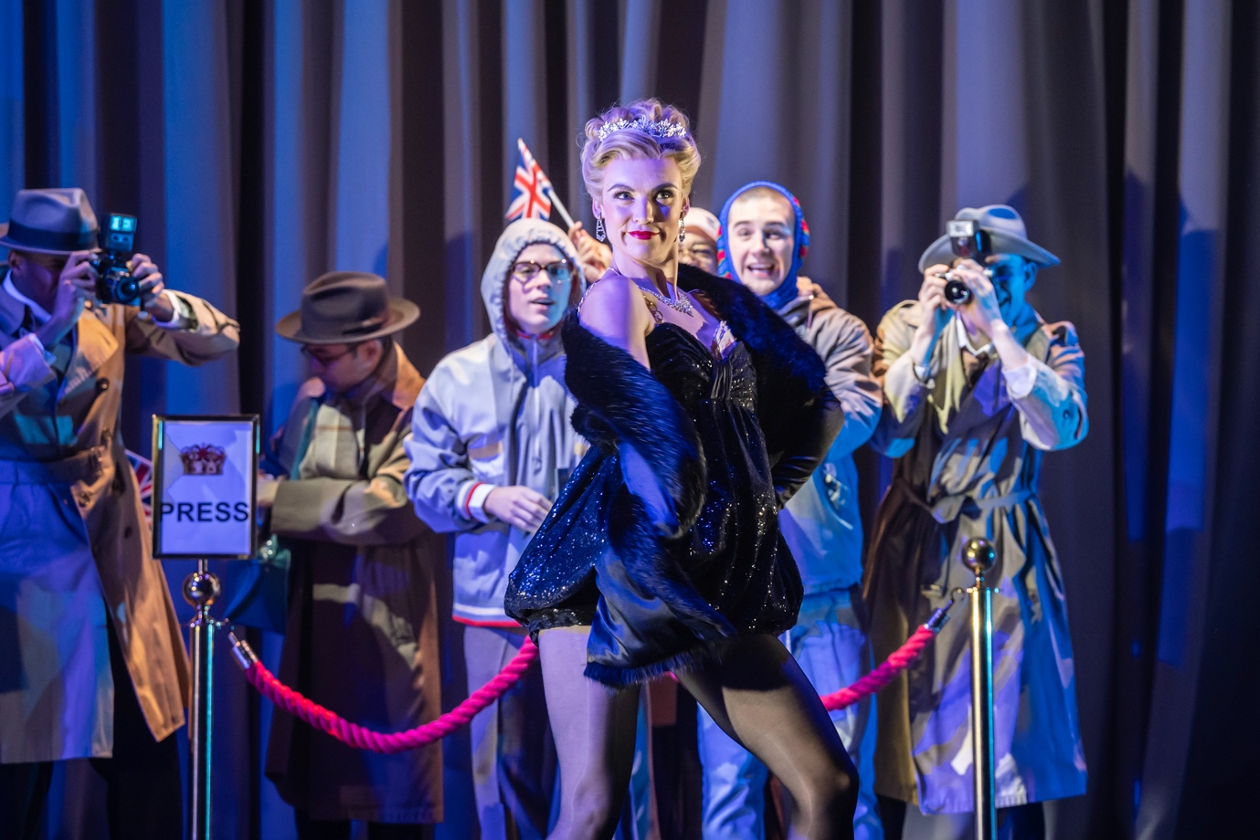
Scene 10 – The Royal Ball
The Prince and The Queen enter the room. The Girlfriend is eager to dance with The Prince, but the Private Secretary intervenes. The Prince, believing that she took the Private Secretary’s bribe money outside the club is also dismissive of her. A fanfare of trumpets heralds the arrival of a mysterious Stranger who looks just like The Swan. He appears to put everyone, including The Queen, under an intoxicating spell with his intrigue and brazen behaviour. The Prince is confused as The Stranger doesn’t seem to recognise him. Eventually, frustrated and disturbed, The Prince draws a gun from his pocket and aims at his mother, but it is the Private Secretary who shoots first – in the frenzy, however, The Girlfriend is the one killed.
TRIGGER WARNING: Two guns appear on stage for 20 seconds. Flashing lights.
SOUND WARNING: Loud fanfare at the start of the ball and when The Stranger appears. One gunshot.
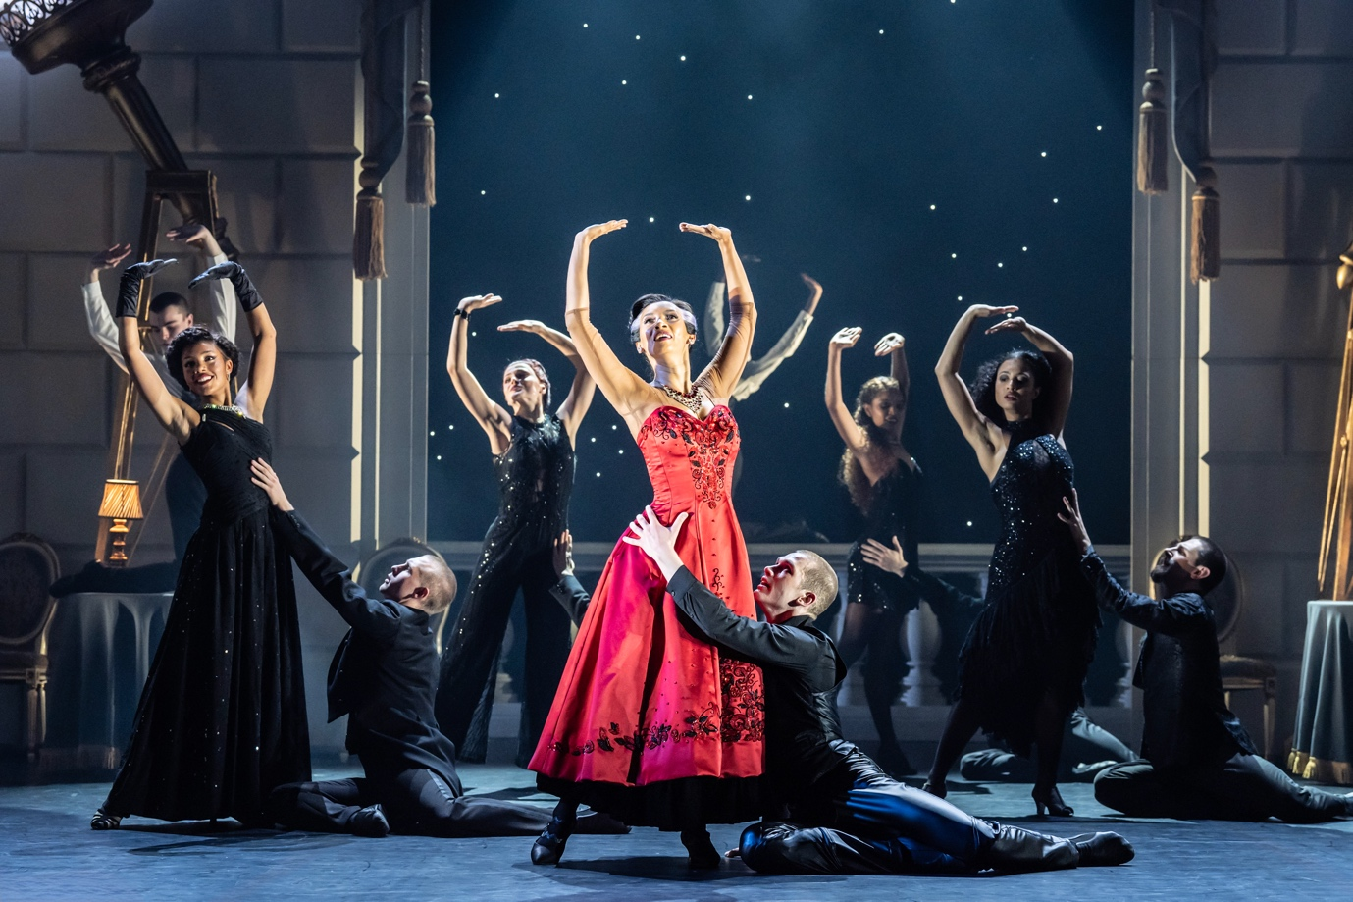
Scene 11 – The Prince’s Bedroom
With bars over his window, The Prince is subjected to sinister attempts to treat his mental illness. Once The Prince is in a deep sleep, the nurses and Private Secretary leave.
As The Prince sleeps, The Swans begin to emerge from around his bed. It seems like he is having a nightmare, and he suddenly sits up in bed to find The Swans have vanished. Then, The Swan tears through The Prince’s bed, emerging exhausted. Almost immediately, the rest of The Swans re-emerge threateningly. They try and eventually succeed in attacking The Swan as The Prince watches in horror. The disappear and The Prince collapses on his bed. The Queen rushes in to find The Prince unresponsive and falls to the floor in grief.
TRIGGER WARNING: Unsettling masks which look like The Queen’s face. Depiction of outdated and violent treatments for mental illness. Fake blood and injury.
SOUND WARNING: Loud crescendo as The Swan emerges from the bed, and again during the attack of the Swans. 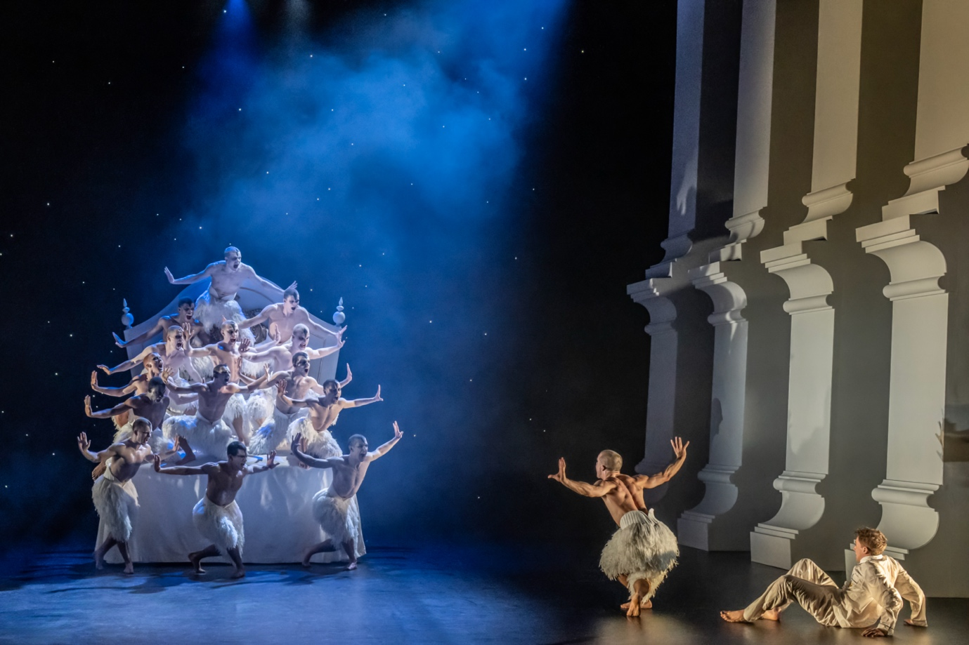

  - THE END
When the show ends, there will be loud clapping and cheering. People may stand up as the performers take a bow.
When you leave the theatre, you might want to talk about what you’ve just seen or take some time to quietly think about it on your own. The story might mean something different to you than it does to other people.

